**FOORPRINTING AND RECONNAISSANCE OF** [**WWW.INTELLIPAAT.COM**](http://www.intellipaat.com) **THROUGH SEARCH ENGINES AND ADVANCED GOOGLE SEARCH:**

**1.GENERAL GOOGLE RESEARCH:**

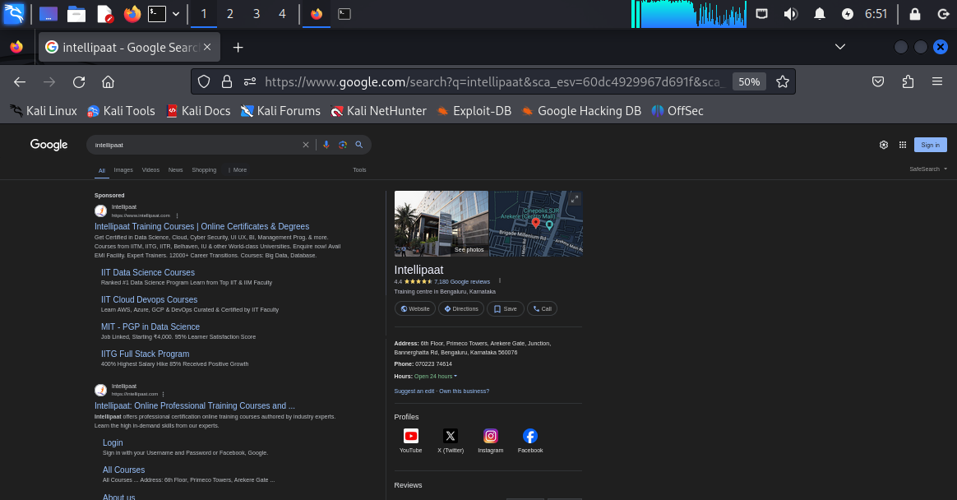

**As we can see that just by typing “intellipaat” on google we have got various websites open regarding intellipaat official website along with different courses and login links,about us tags.**

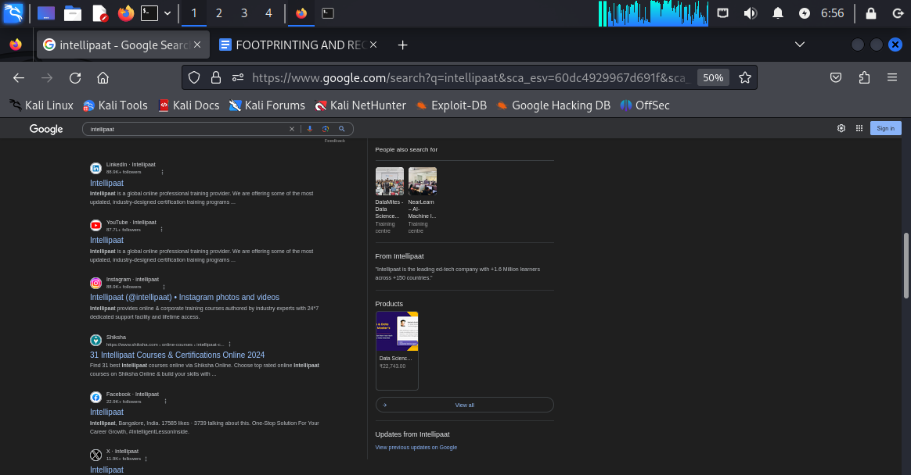

**Also in the second half of the screenshot we can see the webpage contains direct links towards “YOUTUBE VIDEOS”, “FACEBOOK PAGE” ,”INSTAGRAM PAGE”,”LINKEDIN PROFILE”,AND AT THE TOP RIGHT WE HAVE GOT “INTELLIPAAT OFFICE PHYSICAL ADDRESS” ALONG WITH A PICTURE OF THE INTELLIPAAT OFFICE WITH A DETAILED DESCRIPTION.**

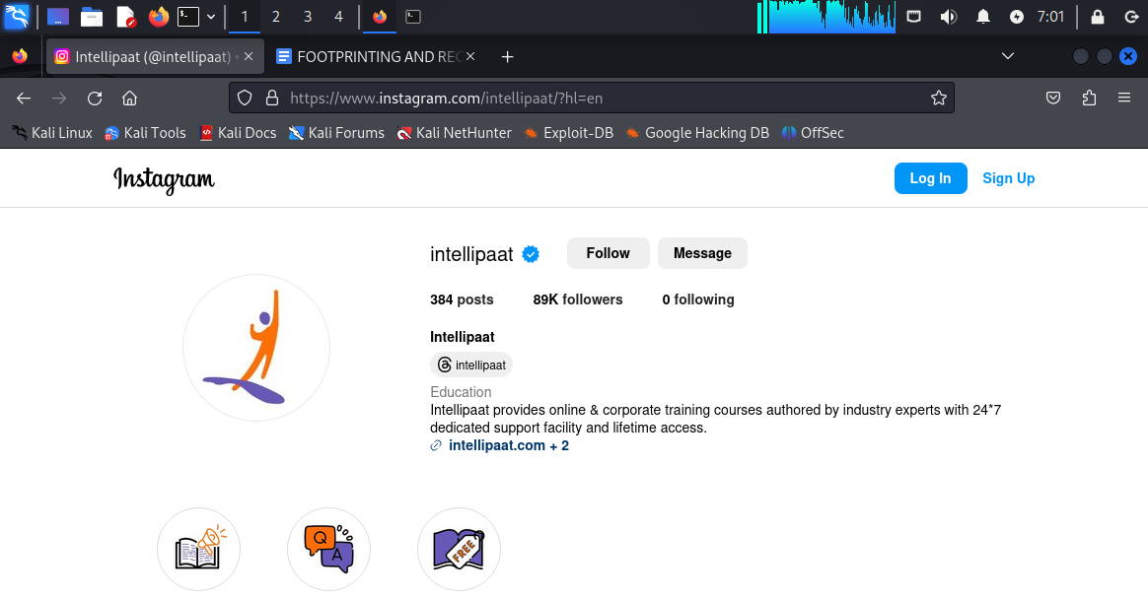

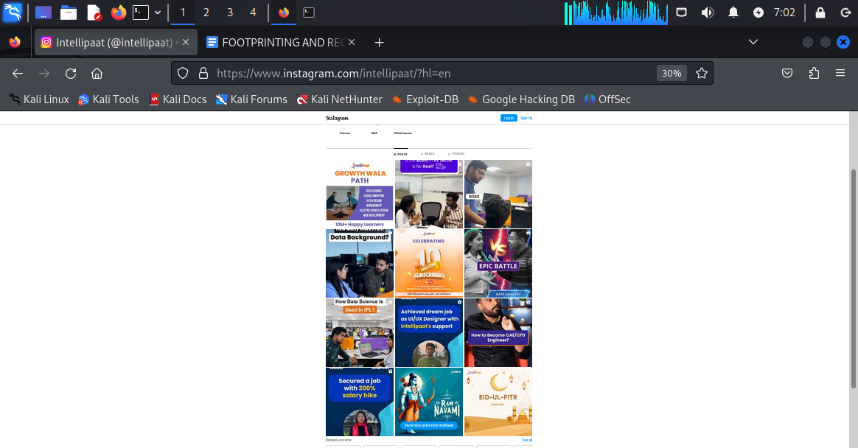

**This is the view of the instagram home page without logging into “instagram”**

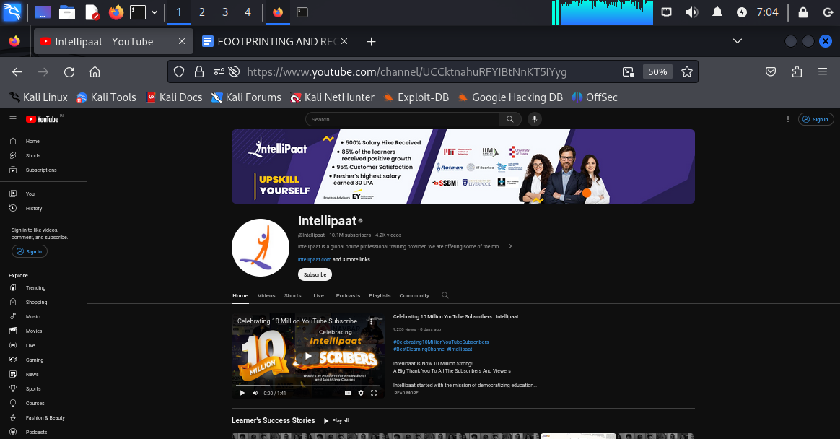

**Youtube channel homepage view with number of subscribers “10.1 M” and number of videos whioch is “4.2K”.**

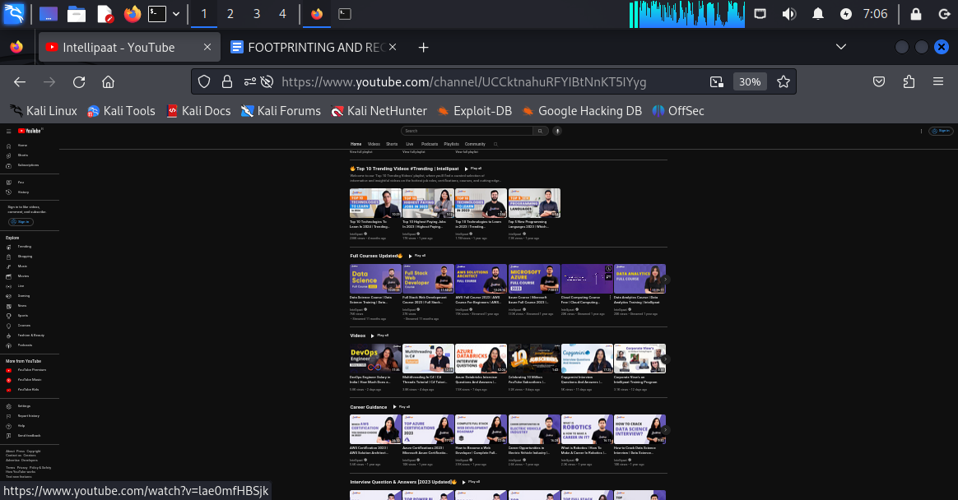

**SECOND SCREENSHOT OF YOUTUBE PAGE WHERE WE CAN SEE DIFFERENT SUB-SECTION LIKE “TOP 10 TRENDING VIDEOS” OR “FULL COURSES UPDATED” , “ CAREER GUIDANCE”**

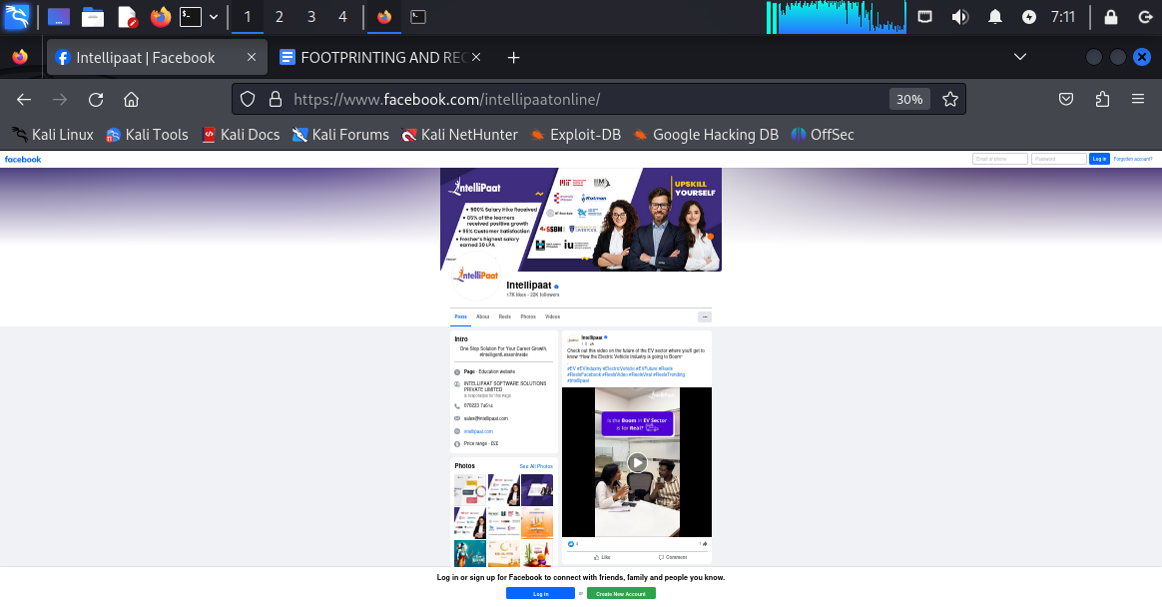

**FACEBOOK HOMEPAGE VIEW WITH INFORMATION SUCH AS “Address”,”phone number”,”website”,”collection of demo images and videos”.**

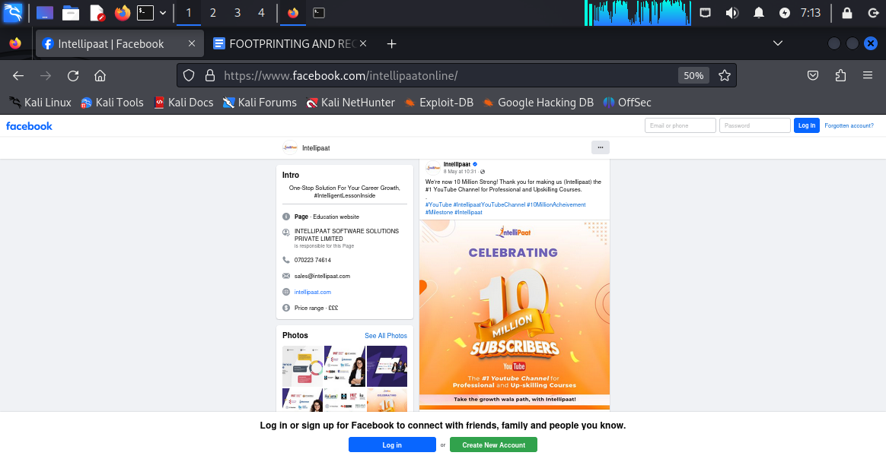

**Updates about latest achievements:**

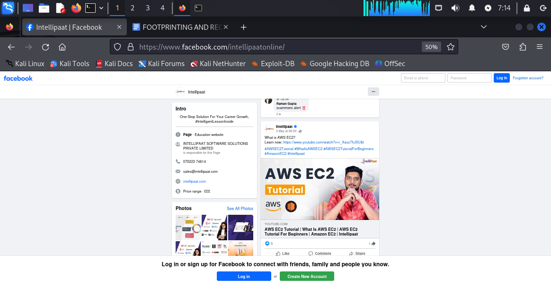

**Short videos and demonstration about latest trendy cloud service like AWS.**

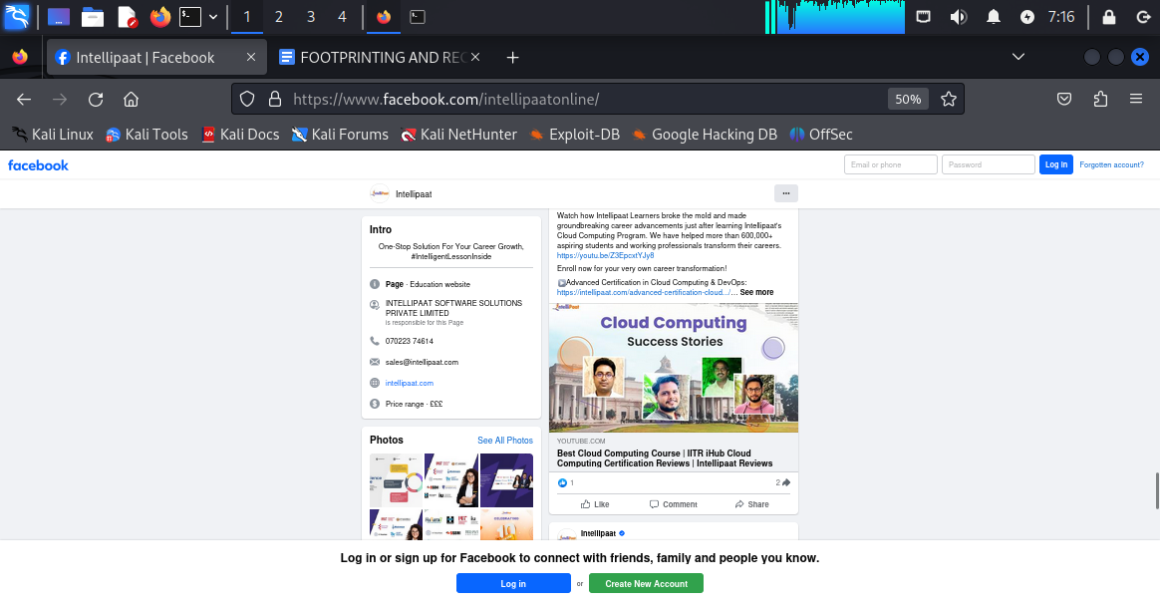

**SUCCESS STORIES AFTER PLACEMENT FROM INTELLIPAAT STUDENTS:**

**2.ADVANCED GOOGLE SEARCH:**

**1. site:intellipaat.com**

**2. related: intellipaat.com**

**3. Intitle: intellipaat**

**4. Allintitle: intellipaat careers**

**5. Inurl : intellipaat**

**6. Allinurl: intellipaat placement**

**7. Intext : intellipaat**

**8. Allintext : intellipaat courses**

**9 .cache: intellipaat.com**

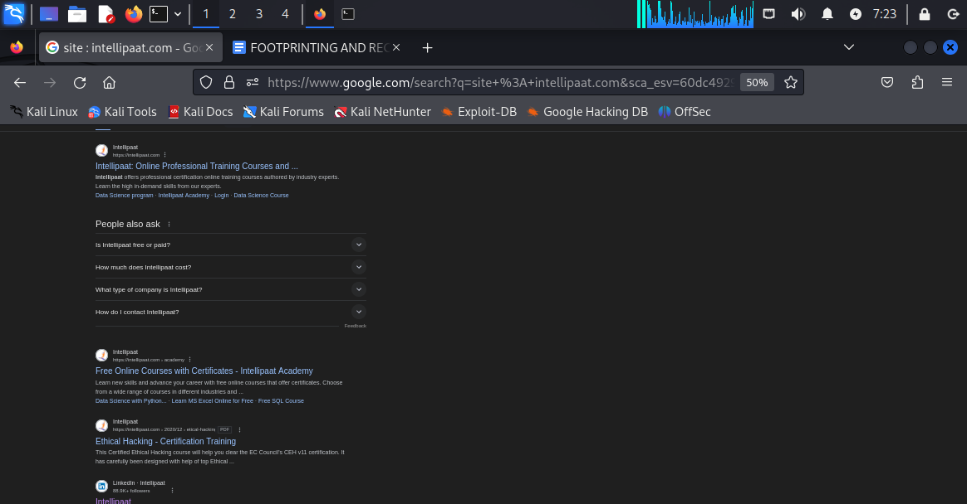

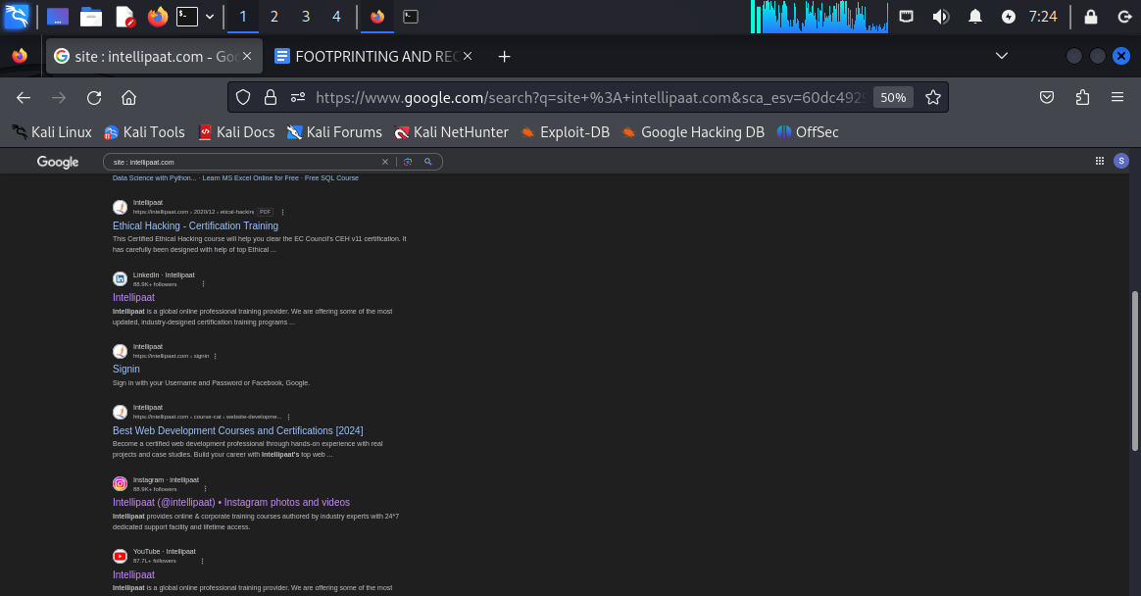

**Result of : site: intellipaat.com**

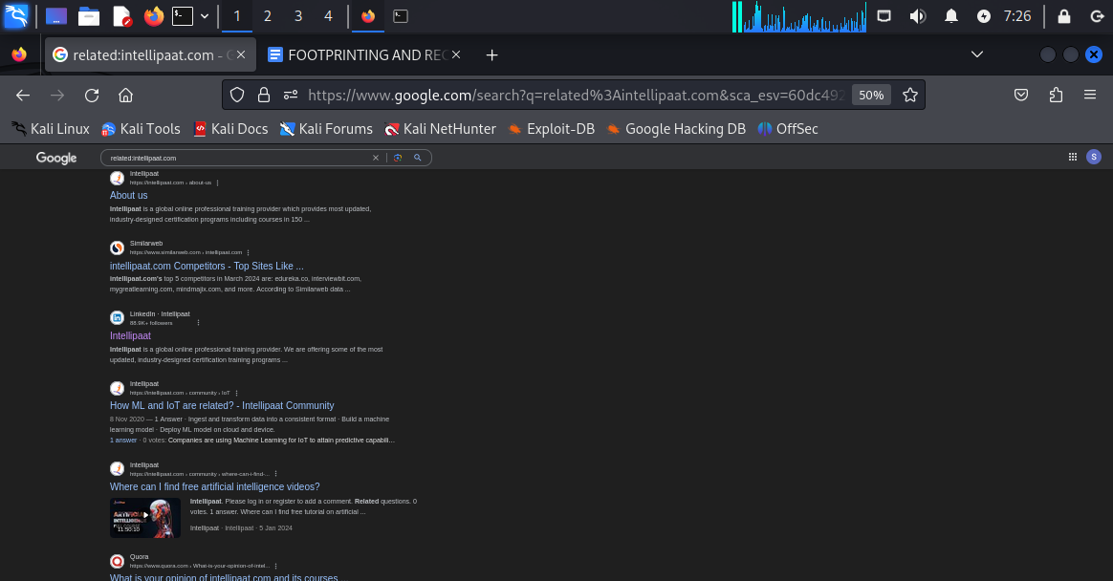

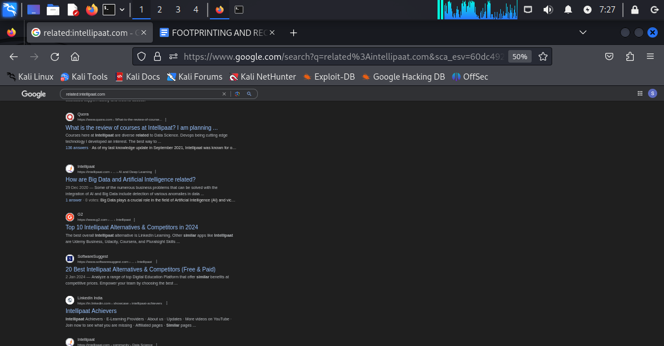

**Result of related:intellipaat.com**

**Observation: for site:intellipaat.com all the searches have come from intellipaat official website , domain and subdomains . we do not see any uploads from any third party website giving info about intellipaat but for related:intellipaat.com we have got the searches not only from intellipaat domain but also from other domains publishing information about intellipaat like “QUORA” , “G2” , “SOFTWARE SUGGEST”,”SIMILARWEB” .These are not intellipaat domains but the information are related to intellipaat .**

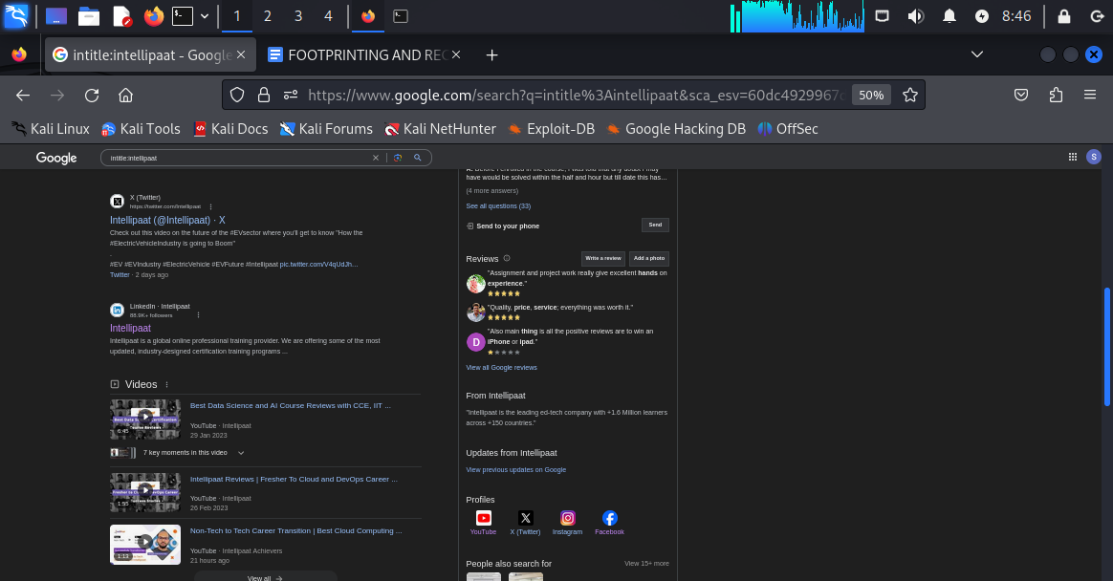

**Results from intitle:intellipaat.com**

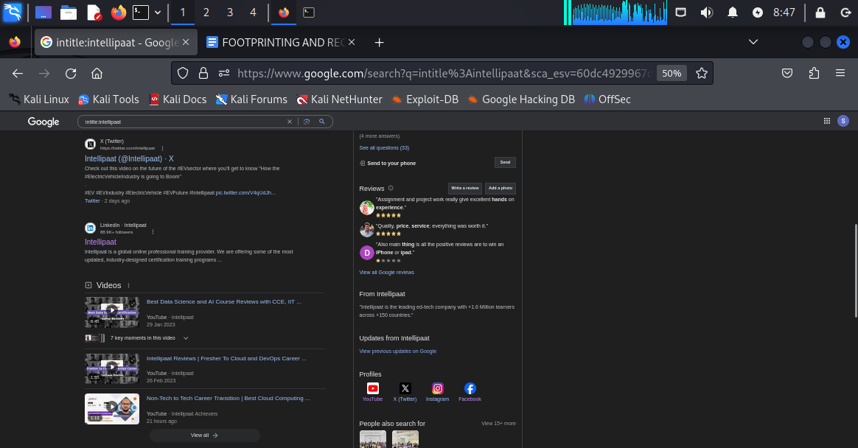

**Results from intitle:intellipaat**

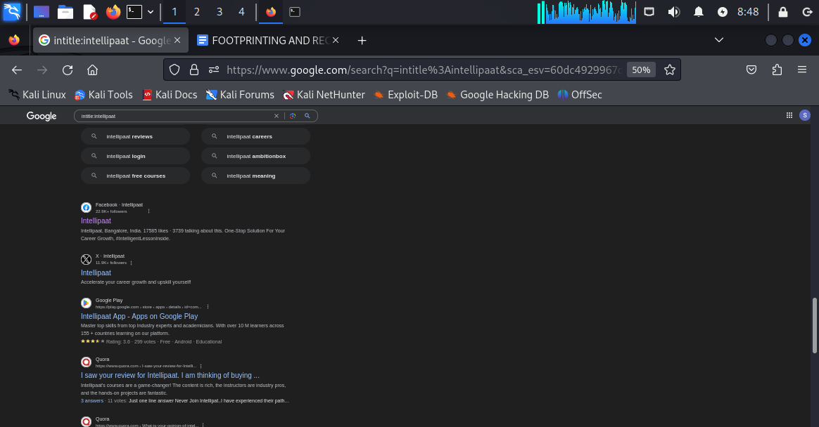

**Results from intitle:intellipaat**

**Observation: the result is the combination of both**

**site:intellipaat.com and related:intellipaat.com. So in the output we have both the combination of the output from intellipaat domain and other domains as well like quora, g2 etc.**

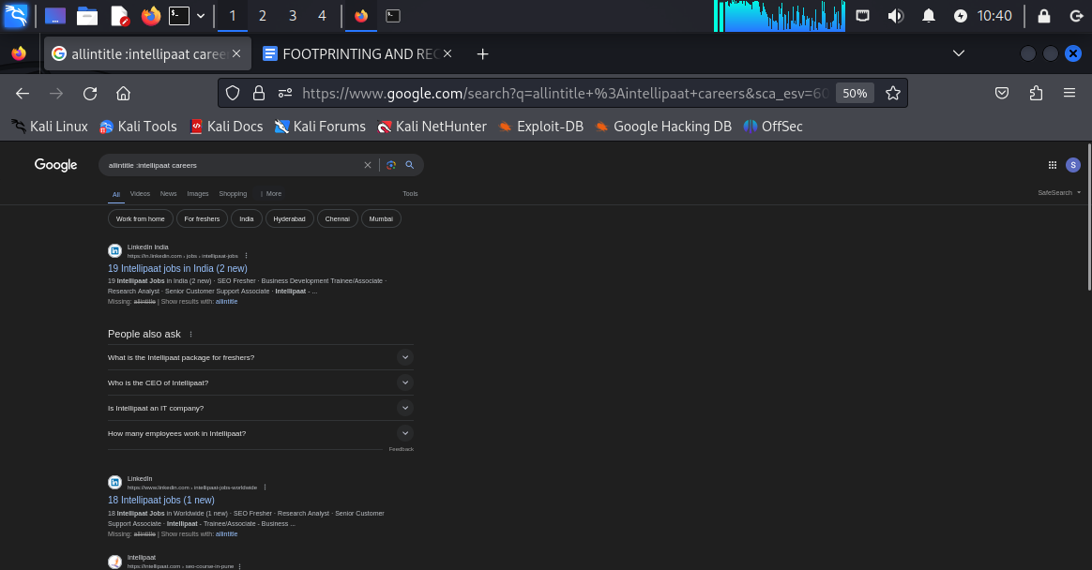

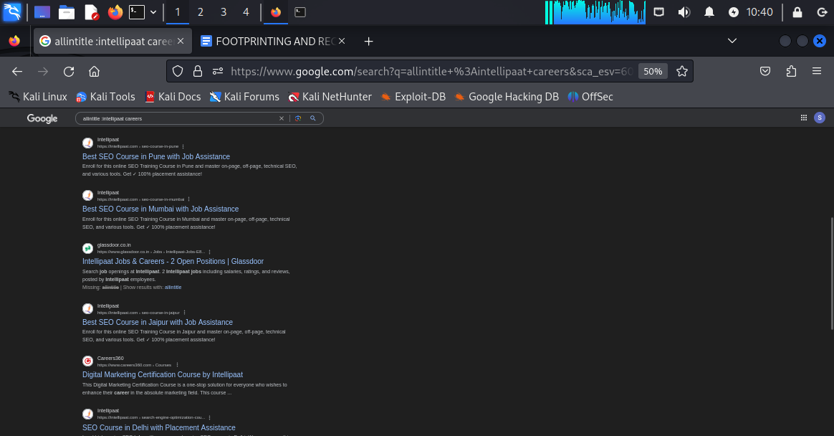

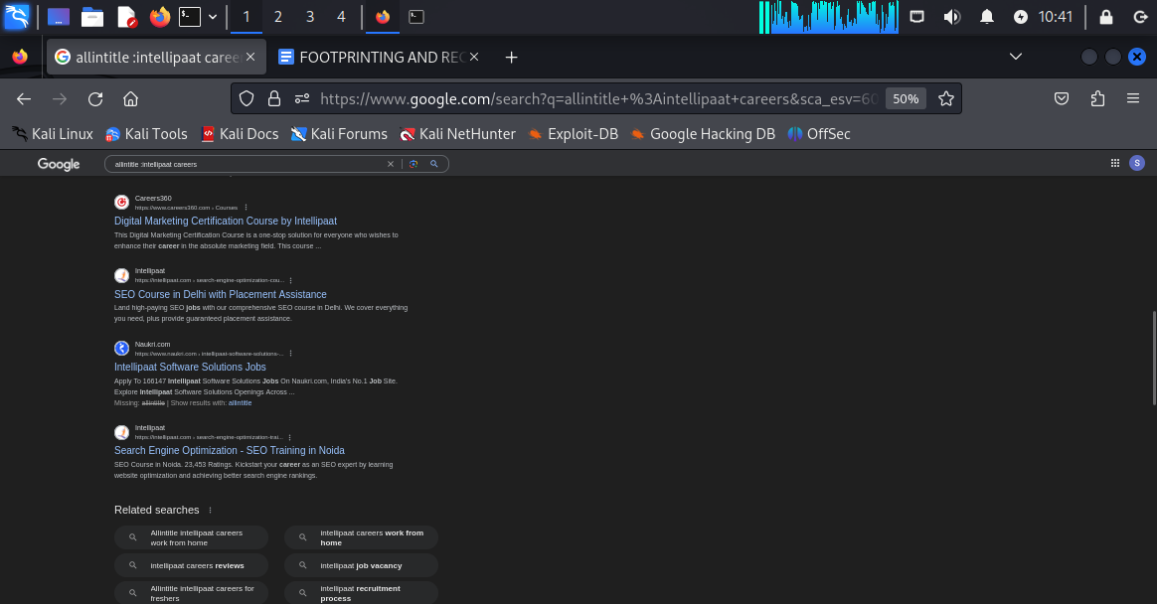

**Results from allintitle: intellipaat careers**

**Observation: we found all the searches related to jobs and careers and placements from intellipaat domain and other domains as well like NAUKRI.COM, CAREERS360, GLASSDOOR.CO.IN AND LINKEDIN INDIA.**

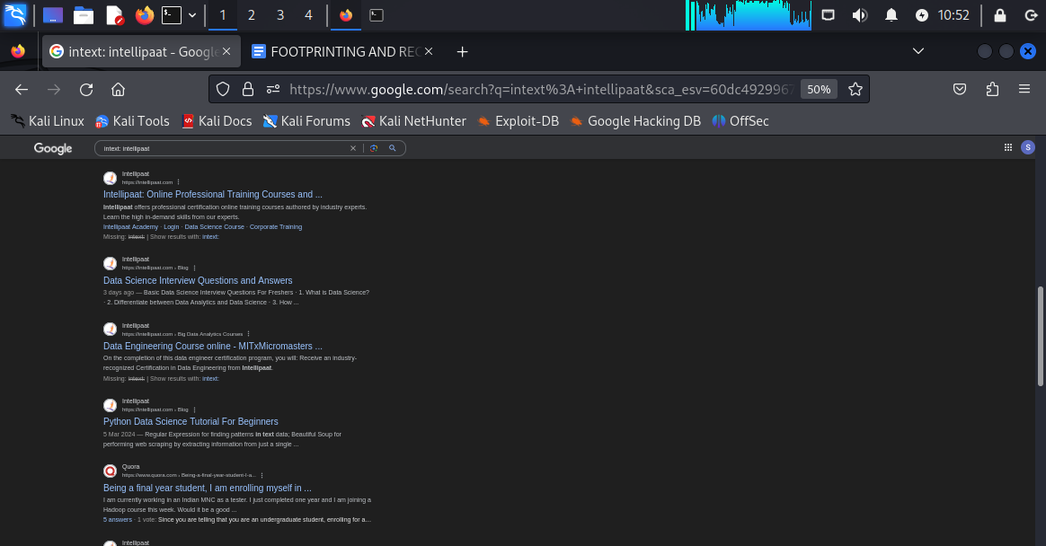

**Results from intext : intellipaat.com**

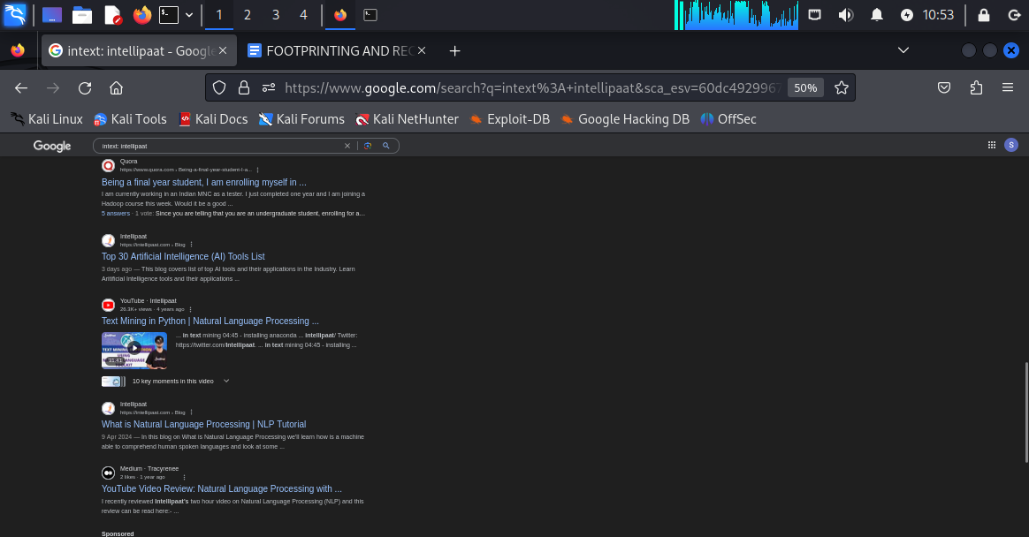

**Results from intext:intellipaat**

**Observation:all the searches are related to intellipaat regarding different topics and sections.**

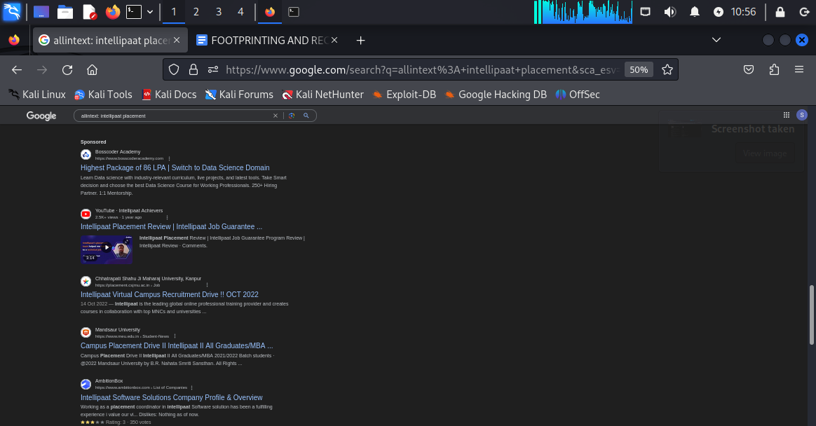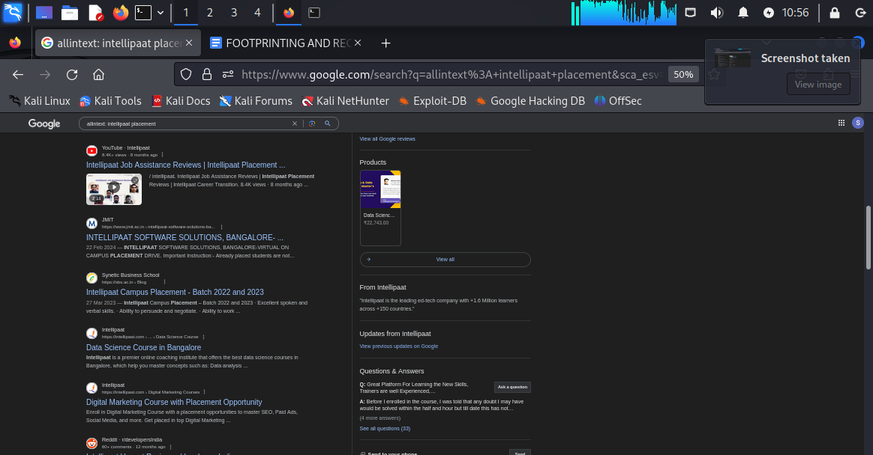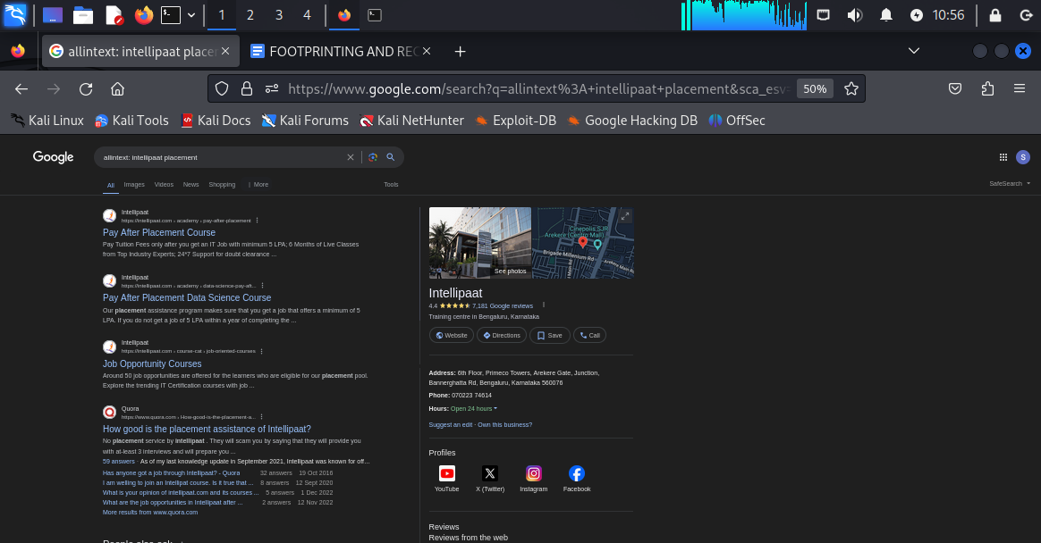

**Results from allintext:intellipaat placement**

**Observation:all the searches are from intellipaat or other domains but absolutely related to jobs and placements of intellipaat.**

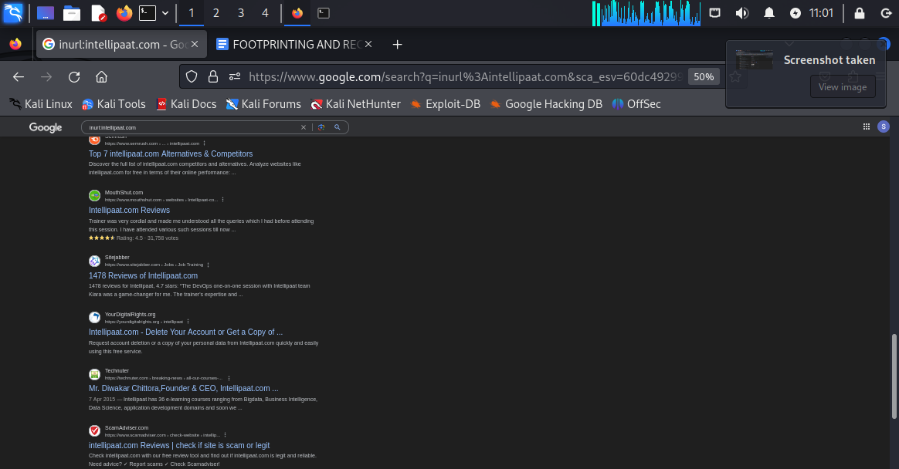

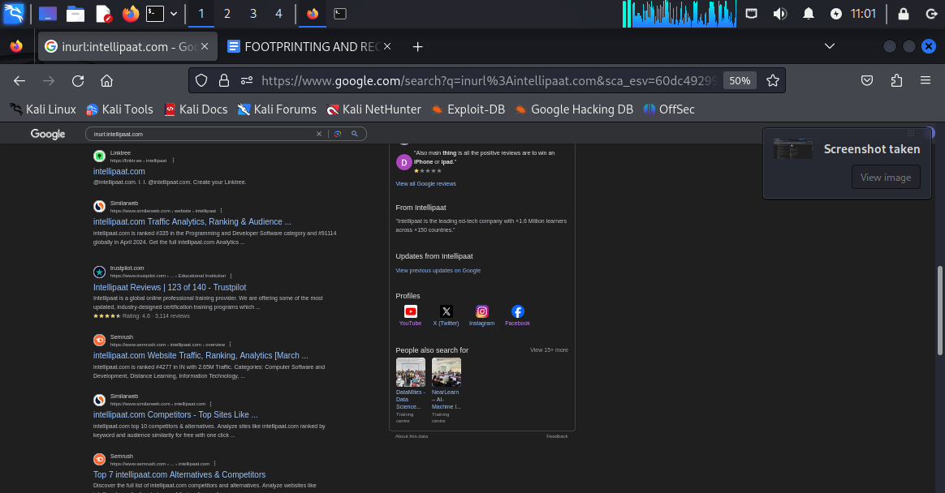

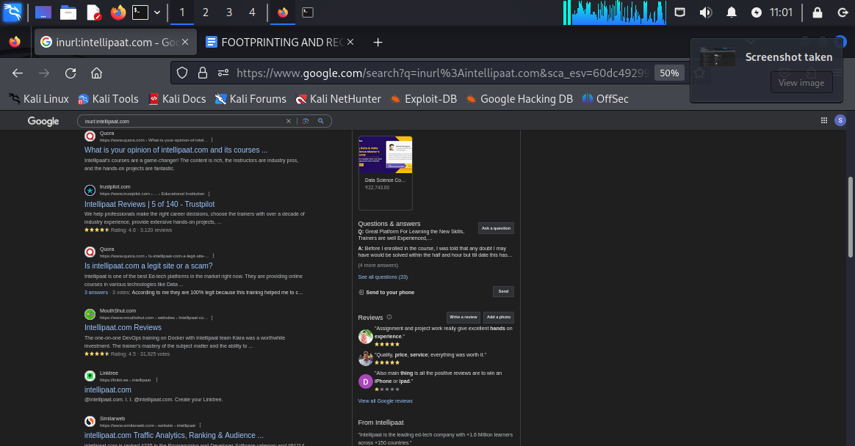

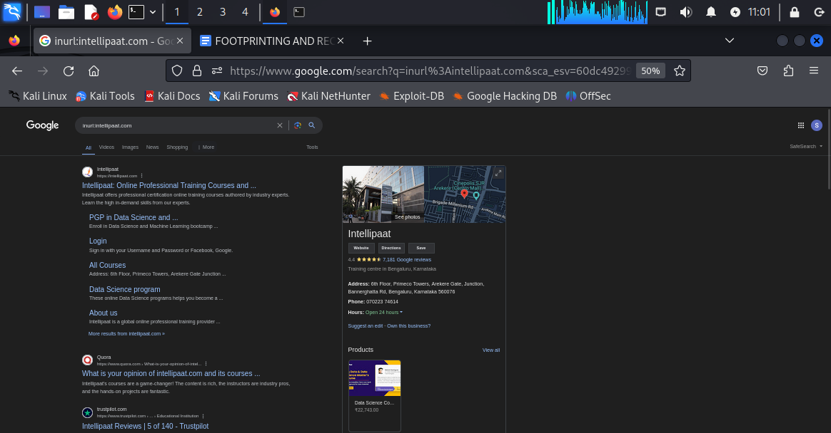

**Results from inurl:intellipaat.com**

**Observation:in this search we have found a handful of other domains like “mouthshut.com”,**

**“trustpilot.com”,”similarweb.com”,”scamadvisosr.com”,”yourdigitalrights.org”etc and all they contain is information about intellipaat.**

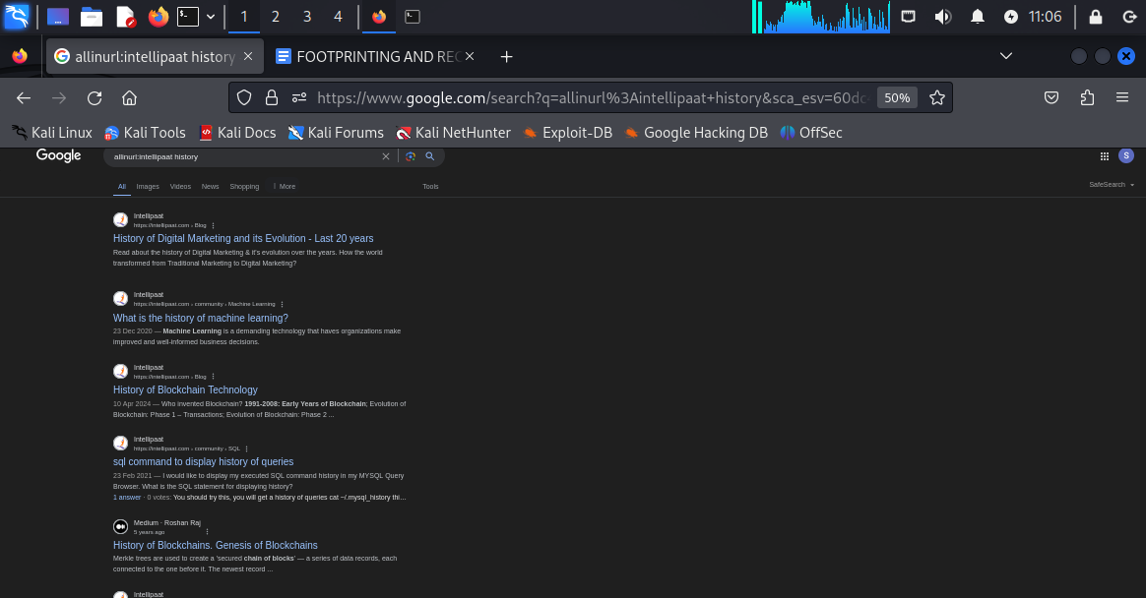

**Results from allinurl:intellipaat history**

**THERE ARE ALSO MANY OTHER ADVANCED GOOGLE SERACHES LIKE**

**1. Define:[word].....it will give the dictionary oriented meaning of that specific word.**

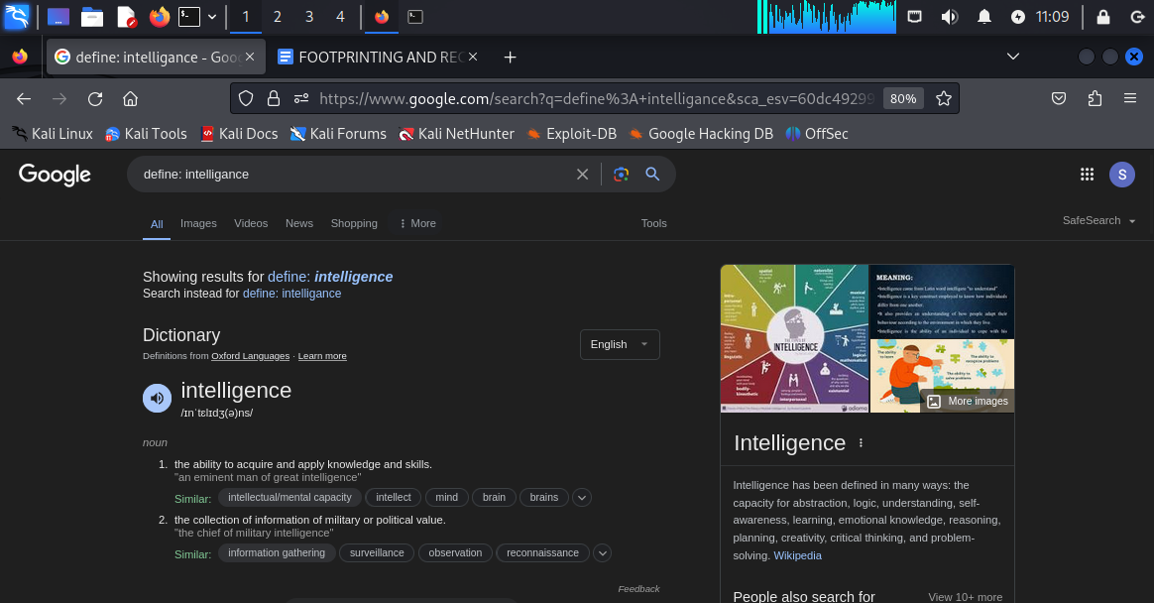

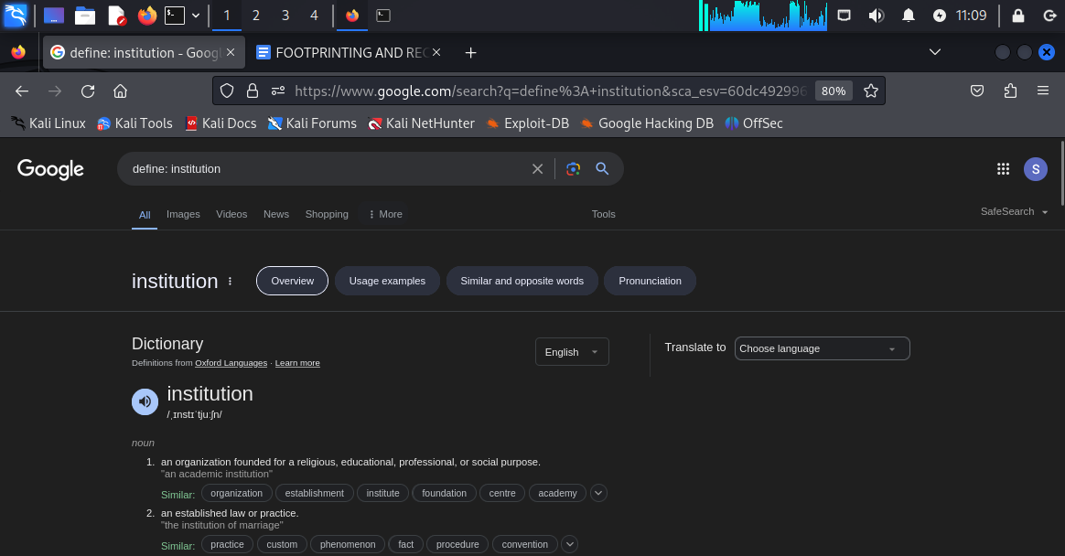

**This is one of the best ways of finding the meaning any word as per dictionary.**

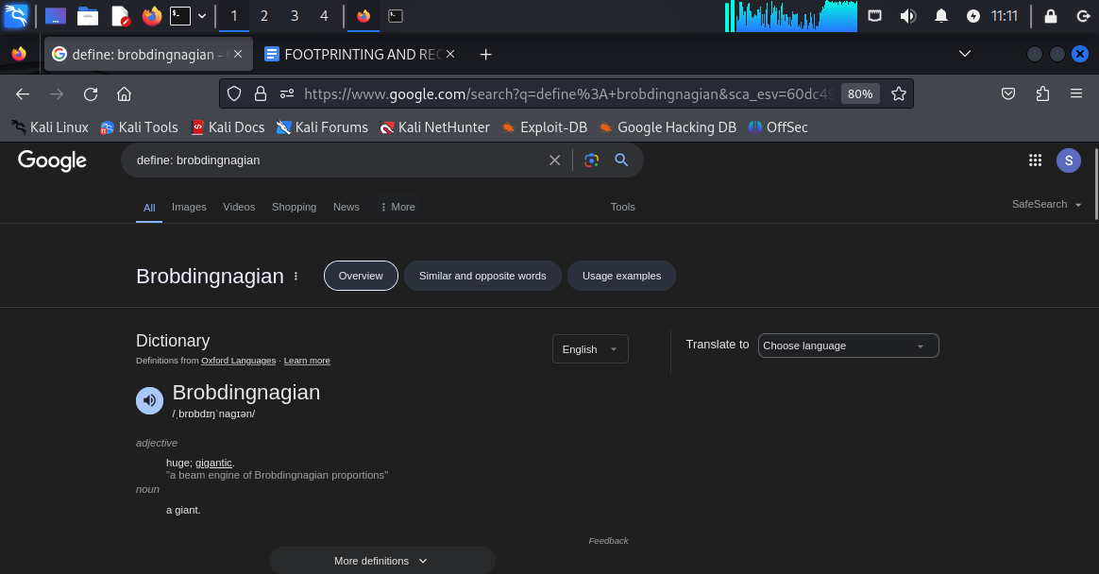

**Another example of the word “brobdingnagian”**

**2. Cache : intellipaat.com ……it will give us the latest cache version of any specific website.**





**Results from cache version of intellipaat.com website**



**This the cache version of netflix.com**

**3.intellipaat filetype:pdf**

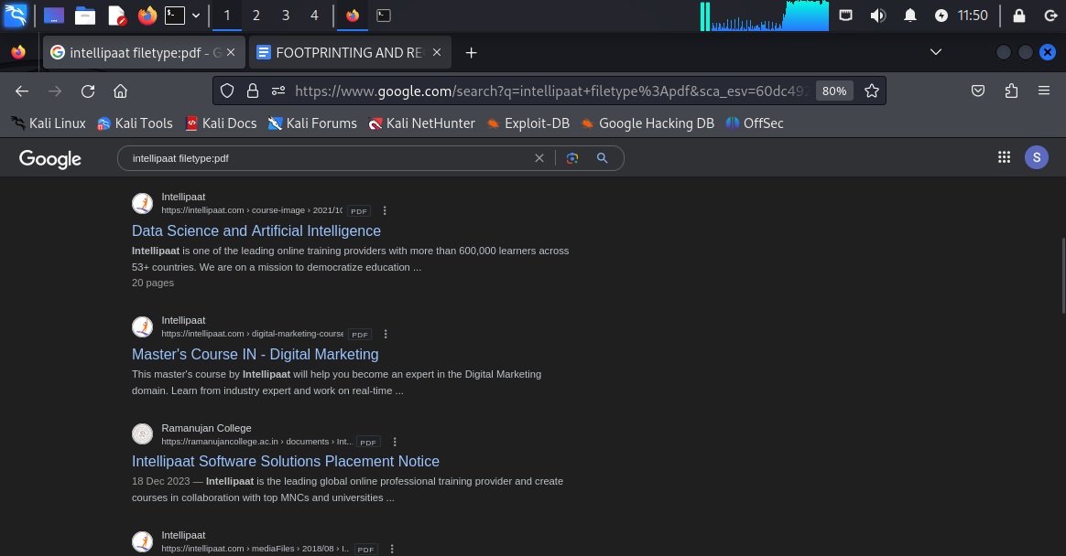

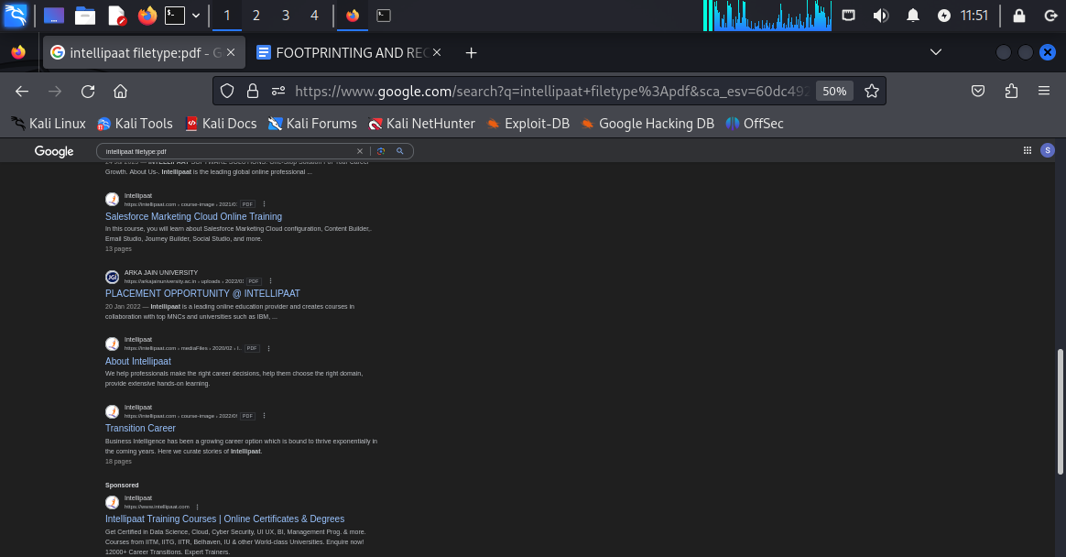

**Results from intellipaat filetype:pdf**

**Observation:we have found the pdf files directly from the web search and just by clicking on that we will be able to see the content of the pdf file.**

**4.weather:[location]**

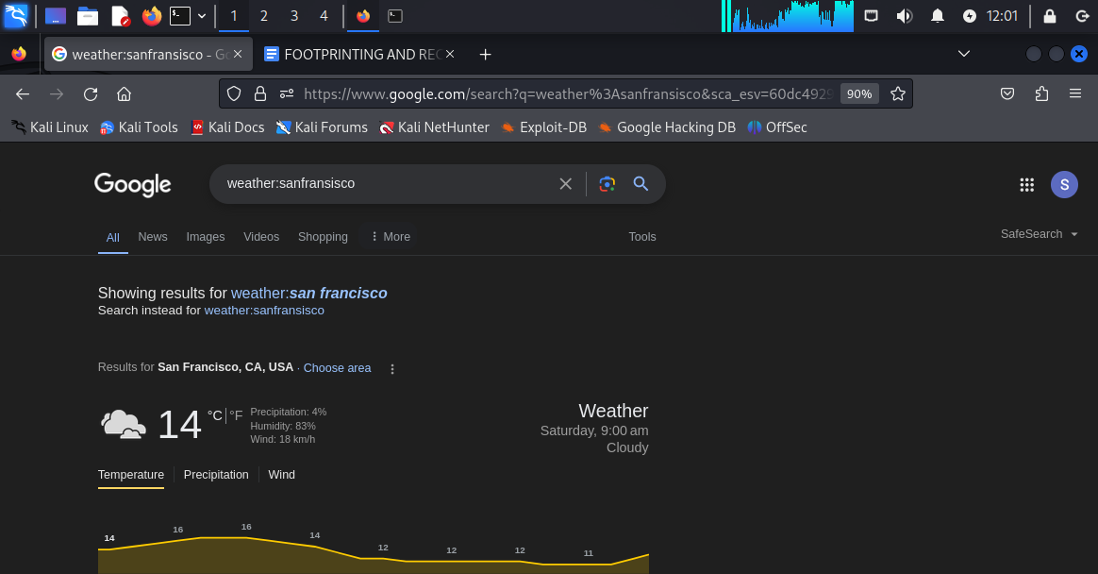

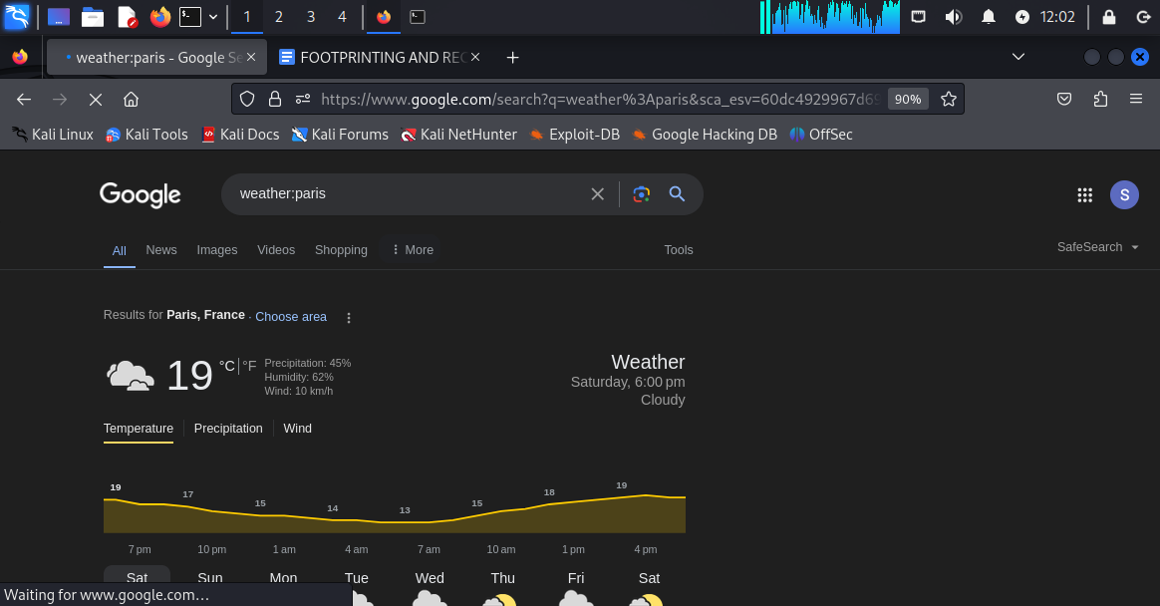

**Results for the weather for san fransisco and paris.**

**5.map[location]**

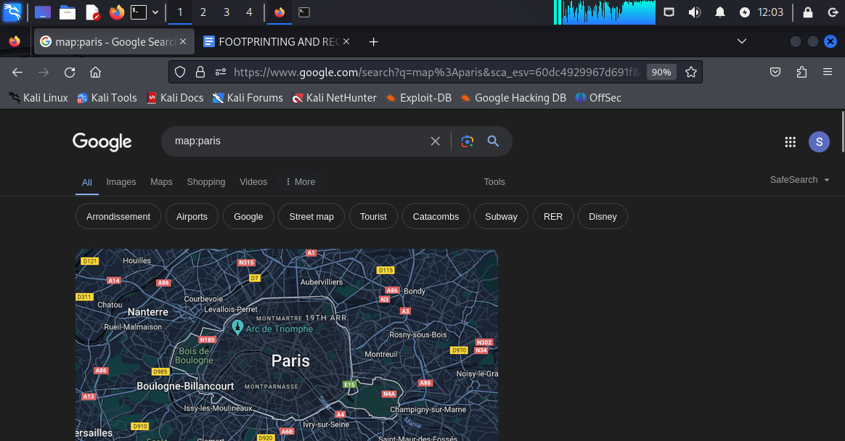

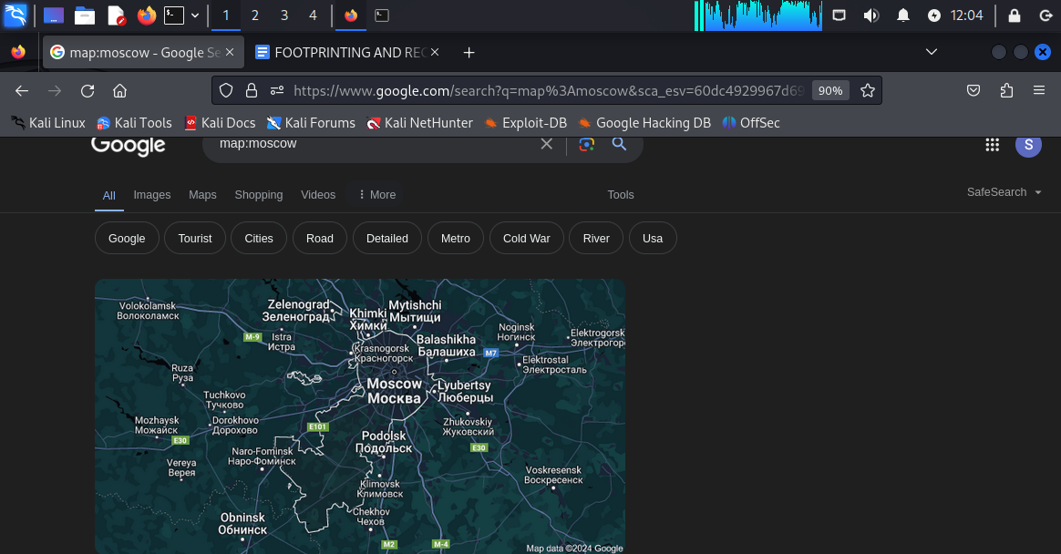

**Results for paris and moscow for map:[location]**

**FOOTPRINTING BY USING VIDEO SEARCH ENGINES BY USING mattw.io website.**

**Step1: first got to yoUTUBE AND SEARCH INTELLIPAAT CAREERS**



**STEP 2: SELECT ANY RANDOM VIDEO LIKE “ GET JOB OFFERS FROM TOP MNCs”**

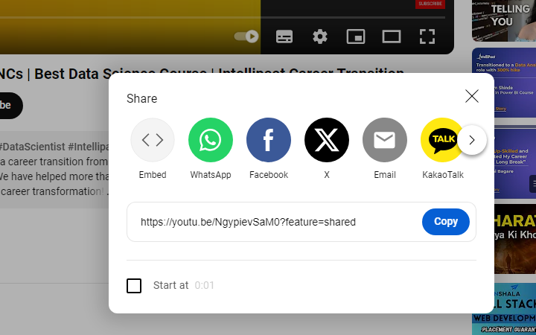

**Now we need to click on share>>then click on copy to copy the code.**

**Step3: go to mattw.io and click on “youtube metadata” and paste the code in the search box.**

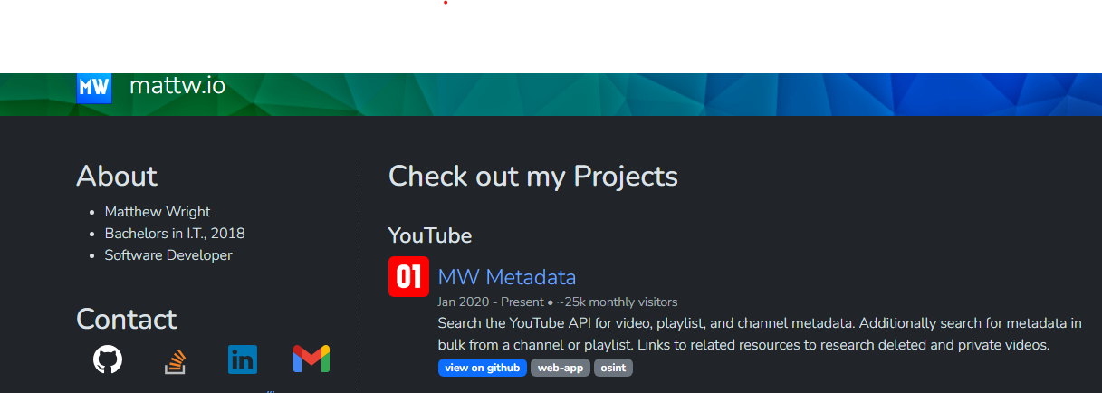

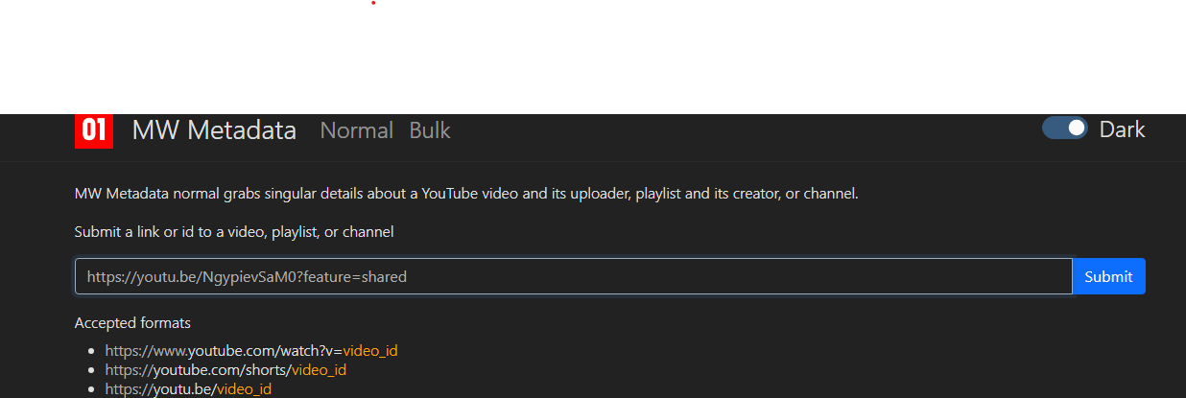

**Step4:after pasting the link in the box we need to click submit to find out all detailed info about this video regarding intellipaat.**

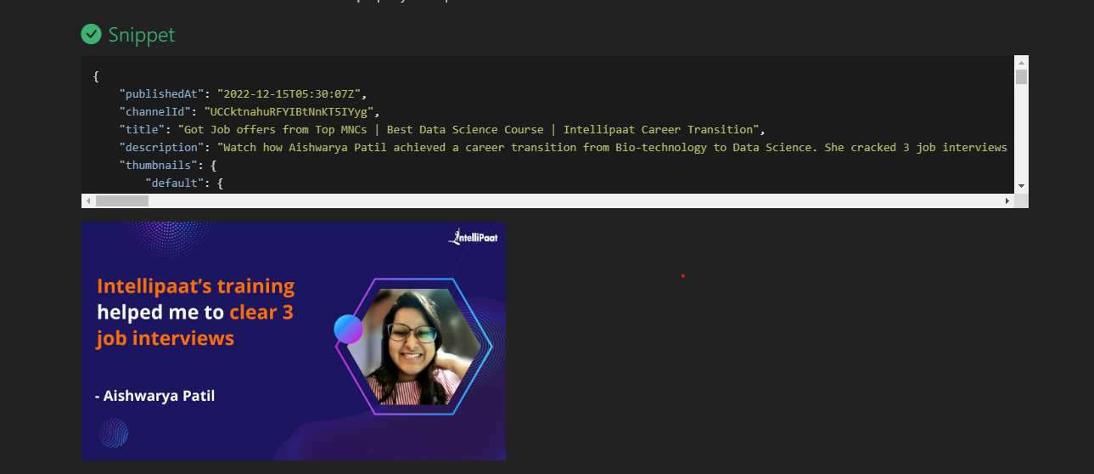

**NECESSARY DETAILS:**

1. **Channel id ::UCCktnahuRFYIBtNnKT5IYyg**
2. **Published date and time:2022-12-15T05:30:07Z**

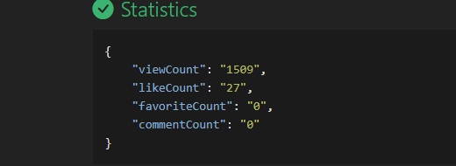

**Information about**

**Viewcount: “1509”**

**Like count: “27”**

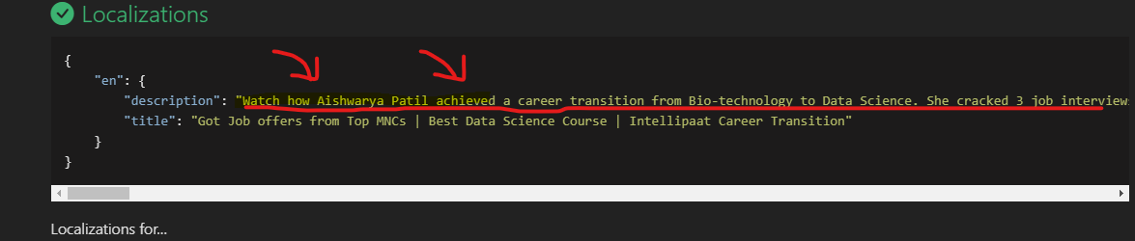

**We can see the main objective of the entire video where a lady named “AISHWARYA PATIL” achieved a career transition from bio-technology to data science and she cracked 3 job interviews.**

**Objectives: without watching the video we can gather all the information or meta data about the video.**

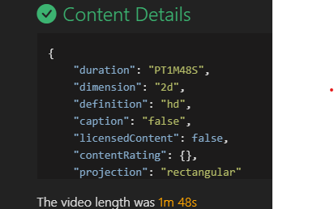

**We can see the graphical description about the video for example dimension and definition and projection**

**Likewise we can do video search about any domain or website with matte.io**

**FOOTPRINTING BY USING** [**www.website.informer.com**](http://www.website.informer.com) **and** [**www.netcraft.com**](http://www.netcraft.com) **and shodan.io**

**1.**[**www.website.informer.com**](http://www.website.informer.com)

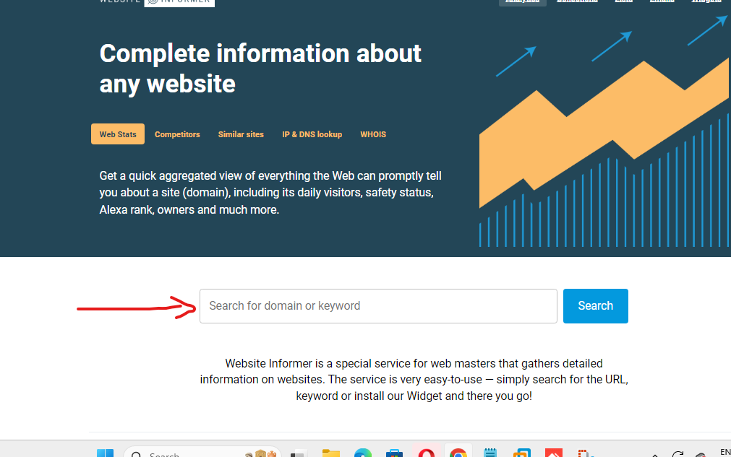

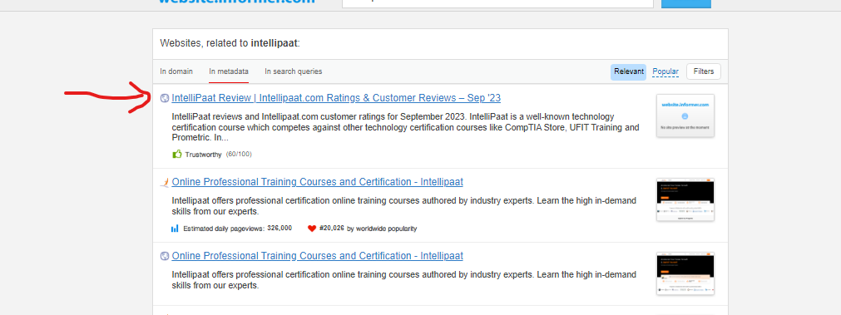

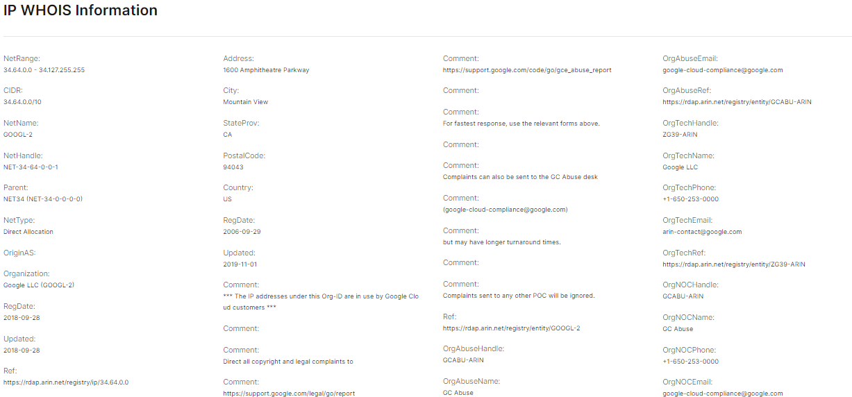

**As we can see that there is a heap of information regarding ONE SPECIFIC INTELLIPAAT WEBPAGE .**

**NETRANGE : 34.64.0.0….34.127.255.255**

**ADDRESS: 1600 AMPITHEATRE PARKWAY MOUNTAIN VIEW CALIFORNIA 94043 USA.**

**REGISTRATION DATE: 29TH SEPTEMBER 2006**

**THESE ARE IP WHOIS INFORMATION**

**2.**[**WWW.NETCRAFT.COM**](http://www.netcraft.com)

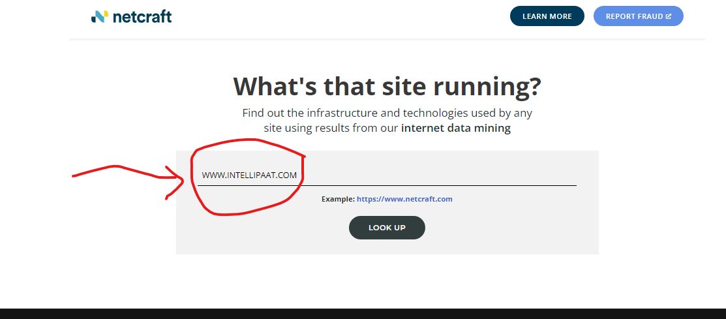

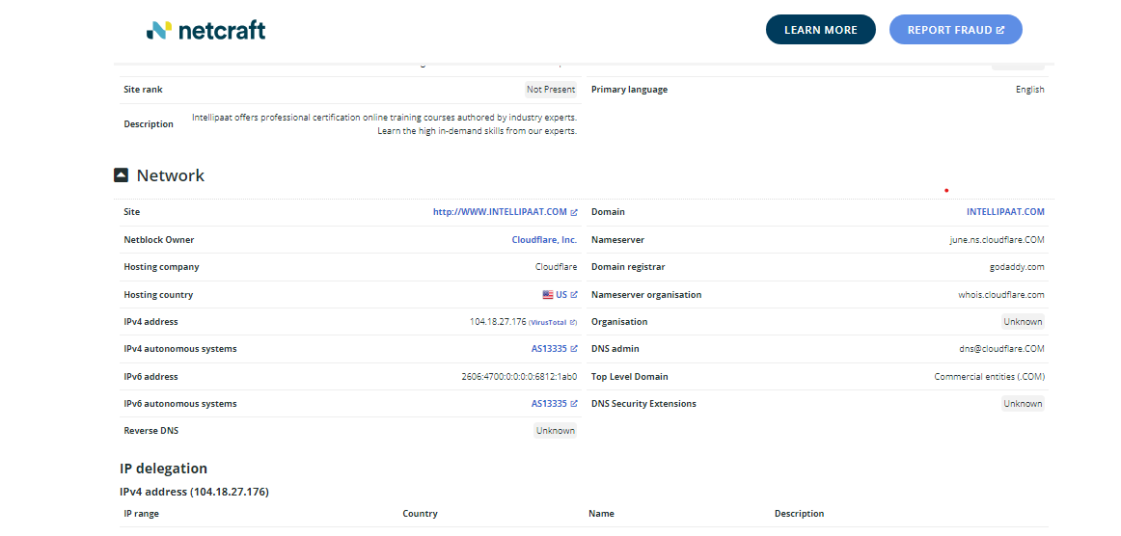

**OBSERVATION:**

**INTELLIPAAT DOMAIN IP ADDRESS:104.18.27.176**

**NETBLOCK OWNER: CLOUDFLARE.INC.**

**IPV6 ADDRESS: 2606:4700:0:0:0:0:6812:1ab0**

**Domain registrar: godaddy.com**

**Dns admin:** [**dns@cloudflare.com**](mailto:dns@cloudflare.com)

**NEGATIVE REVIEWS ABOUT INTELLIPAAT FROM DIFFERENT SURVEY ORIENTED WEBSITES SUCH AS trustpilot.com , glassdoor.co.in or mouthshut.com**

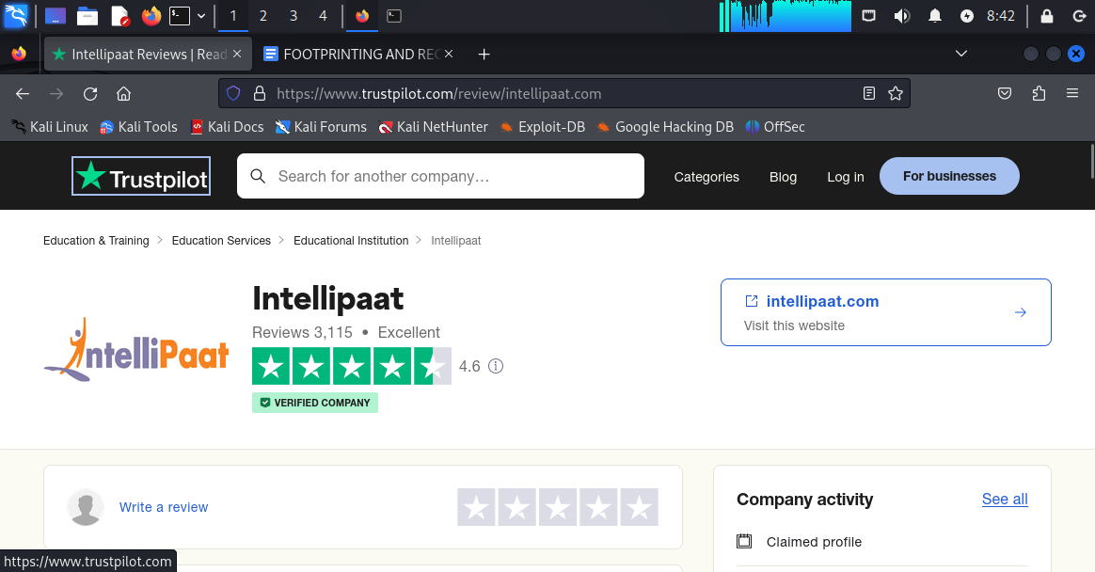

**4.5 out of 5 in trustpilot.com**

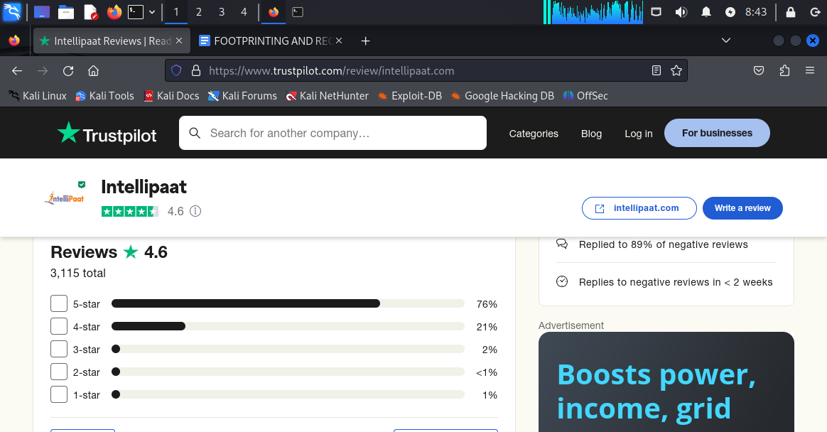

**Percentage based on rating**

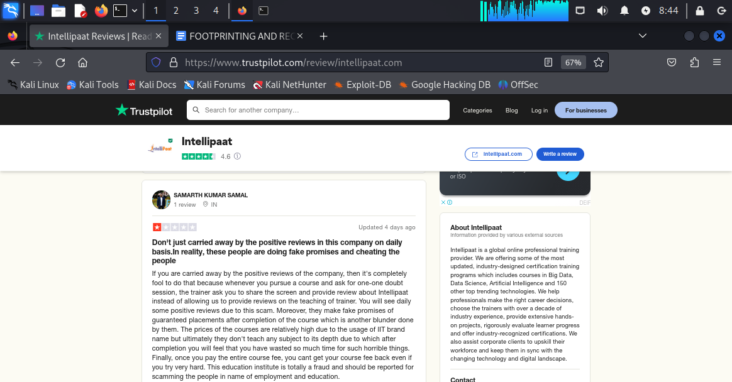

**One negative review about intellipaat**

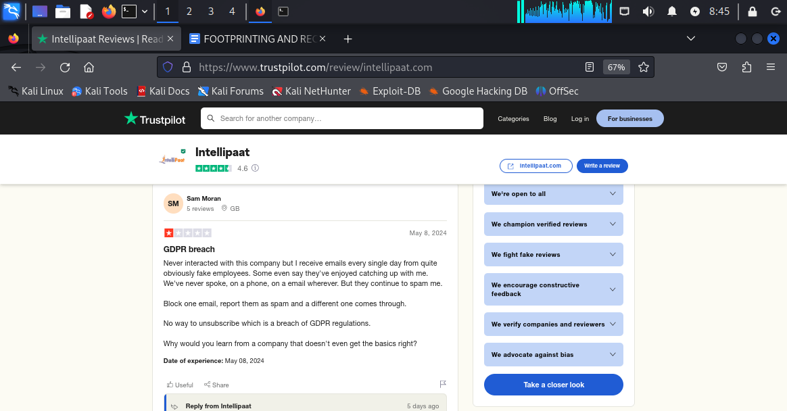

**Second negative review about intellipaat**

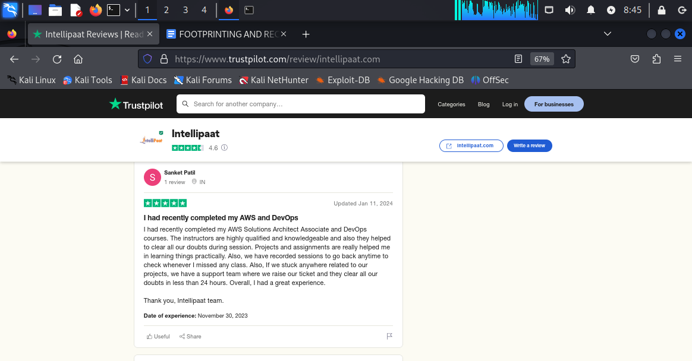

**Positive feedback about intellipaat.**

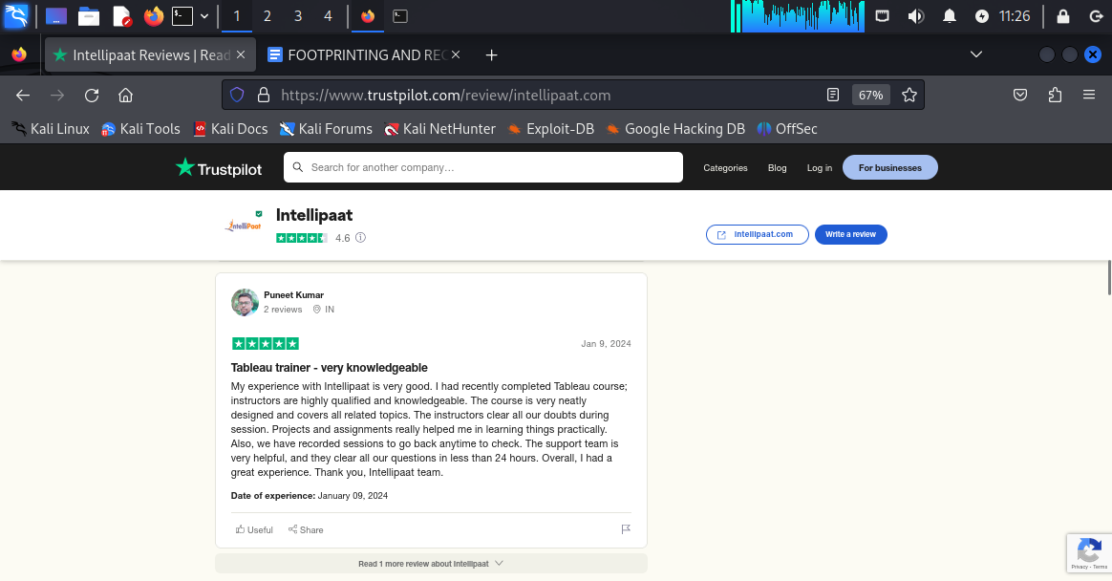

**Positive feedback about intellipaat.com**

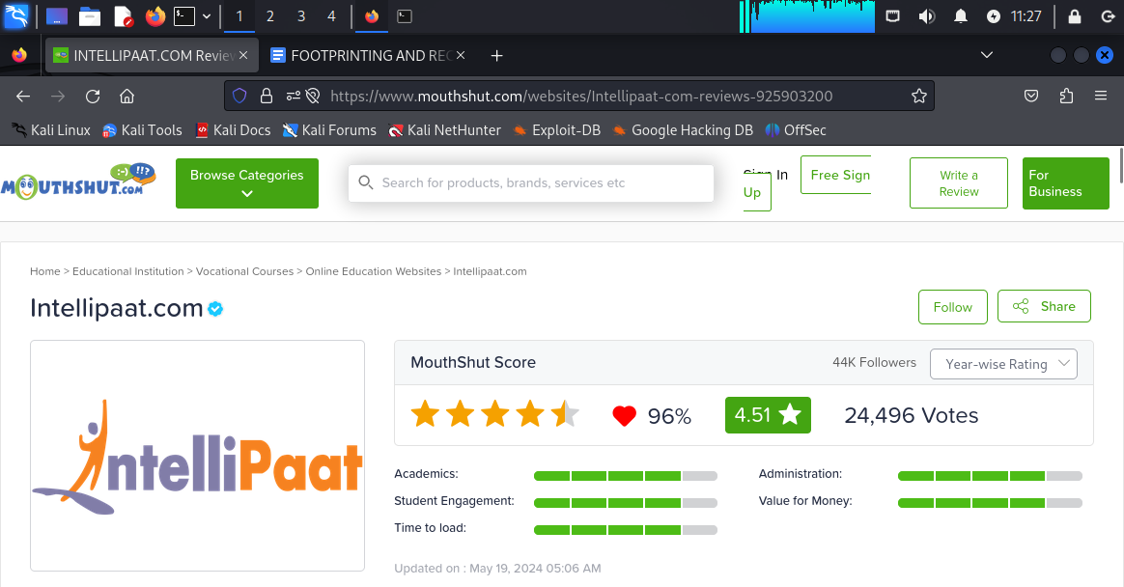

**mouthshut.com statistics.**

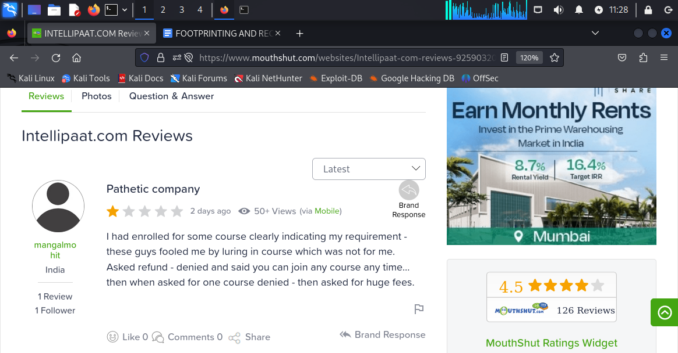

**Negative reviews about intellipaat.com**

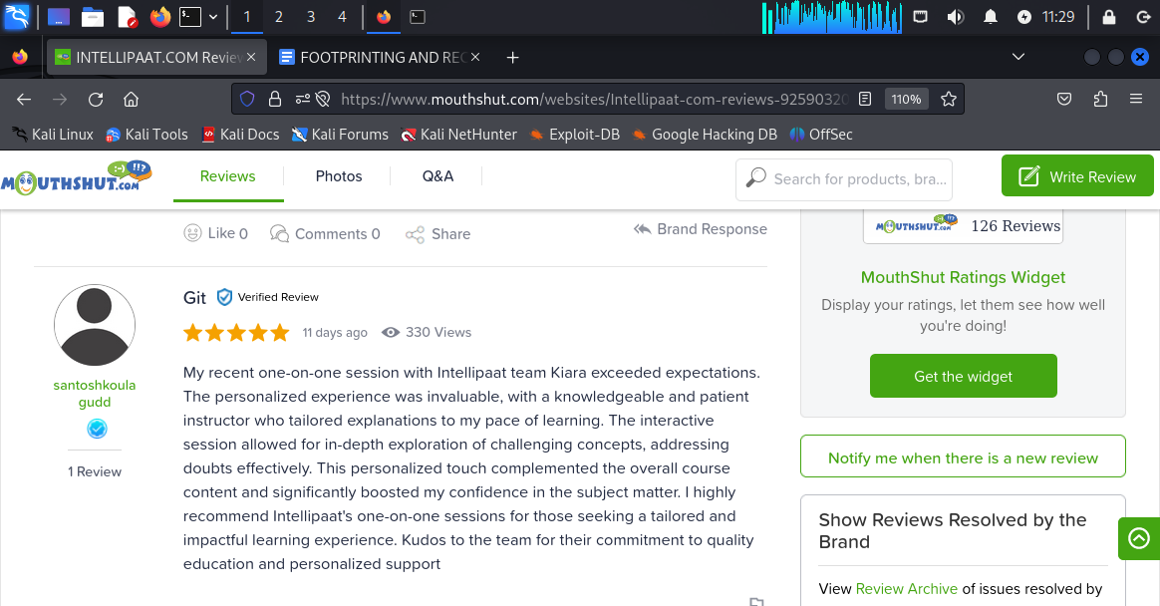

**Positive review about intellipaat.**

**This is how we can collect the information about the public review of a specific domain by using the advanced google search which is reviews:intellipaat[domain name]**

**FINDING OUT INFORMATION BY USING theHarvester command IN KALI LINUX**

**[EMAIL ADDRESS SEARCH]**

**COMMAND: theHarvester -d [domain name] -l [number of search] -b [source]**

**Actual command used in kali linux:**

**theHarvester -d intellipaat.com -l 200 -b hackertarget**

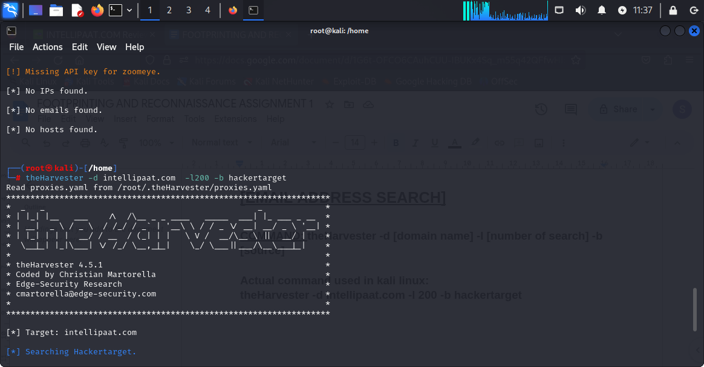

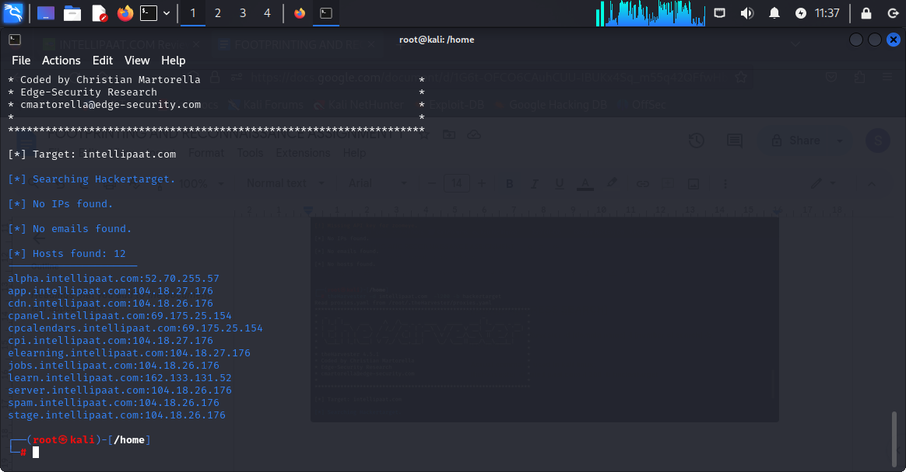

**These are the potential hosts found along with ipv4 address regarding intellipaat from the source hackertarget by using theHarvester tool.**

**HTTP HEADER ANALYSIS OF INTELLIPAAT WEBSITE:**

**THE MOST EFFECTIVE WAY OF ANALYSING HEADER OF INTELLIPAAT WEBSITE OR ANY WEBSITE IS BY USING SHCHECK.PY COMMAND.**

**STEP1: GO TO GITHUB AND COPY THE CODE WHICH IS**

[**https://github.com/santoru/shcheck.git**](https://github.com/santoru/shcheck.git)

**STEP2: GO TO KALI LINUX>>git clone [code]>>chmod 777 shcheck**

**STEP3: ls>>cd shcheck>>ls>>find out shcheck.py**

**STEP4: python3 shcheck.py** [**http://www.intellipaat.com**](http://www.intellipaat.com)

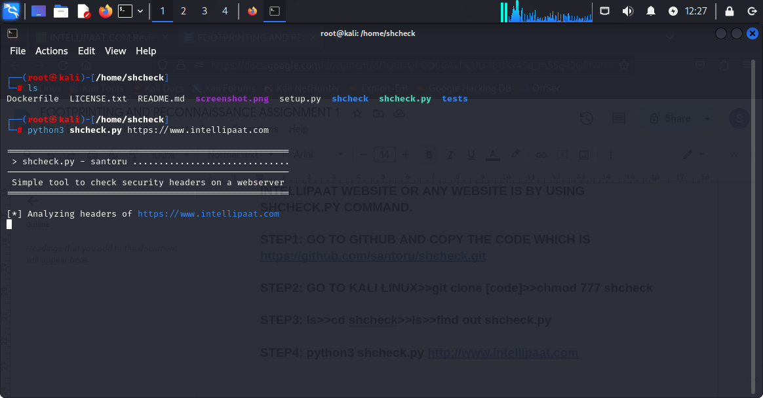

**Command: python3 shcheck.py** [**https://www.intellipaat.com**](https://www.intellipaat.com)

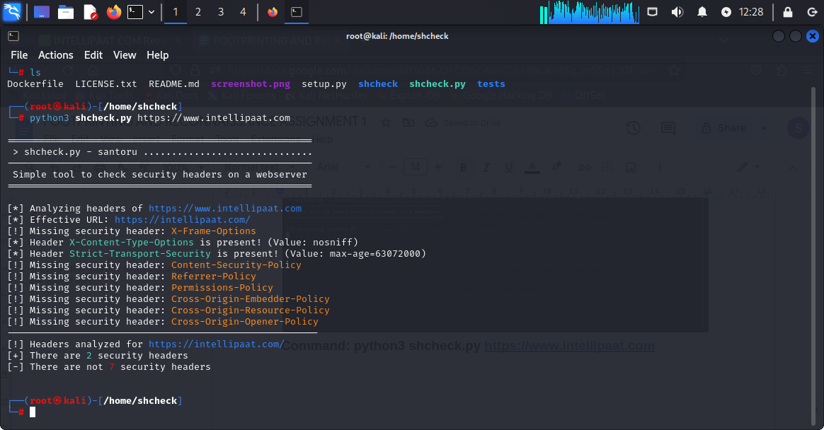

**Observation:**

**1.there are two security protocols present**

**2.seven security protocols are missing**

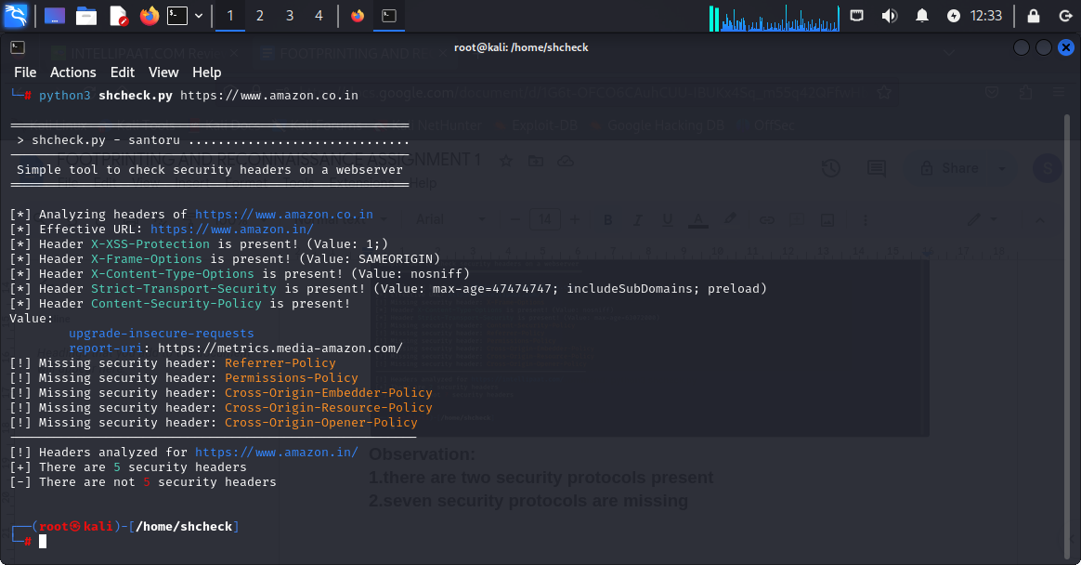

**Analysis of** [**www.amazon.co.in**](http://www.amazon.co.in) **HEADER ANALYSIS.**

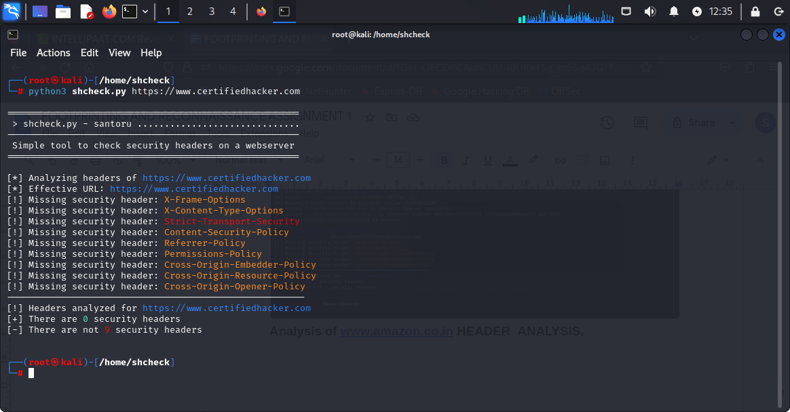

**Results of** [**www.certifiedhacker.com**](http://www.certifiedhacker.com)

**Using “ASHOK” FOR INFORMATION GATHERING AND RECONNAISSANCE OF INTELLIPAAT WEBSITE:**

**Command:**

1. **Git clone [code]**
2. **Chmod 777 Ashok**
3. **ls**
4. **Python3 -m pip install -r requirements.txt**
5. **Python3 Ashok.py - - header** [**https://www.intellipaat.com**](https://www.intellipaat.com)

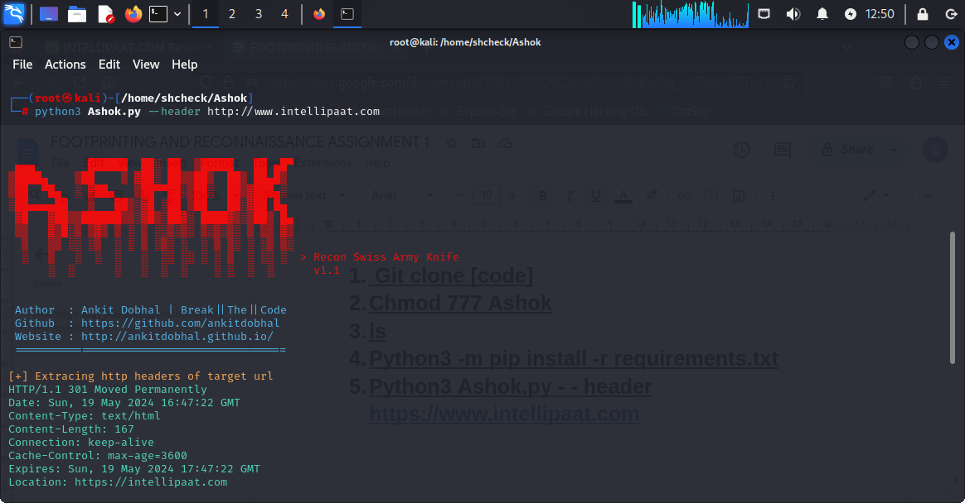

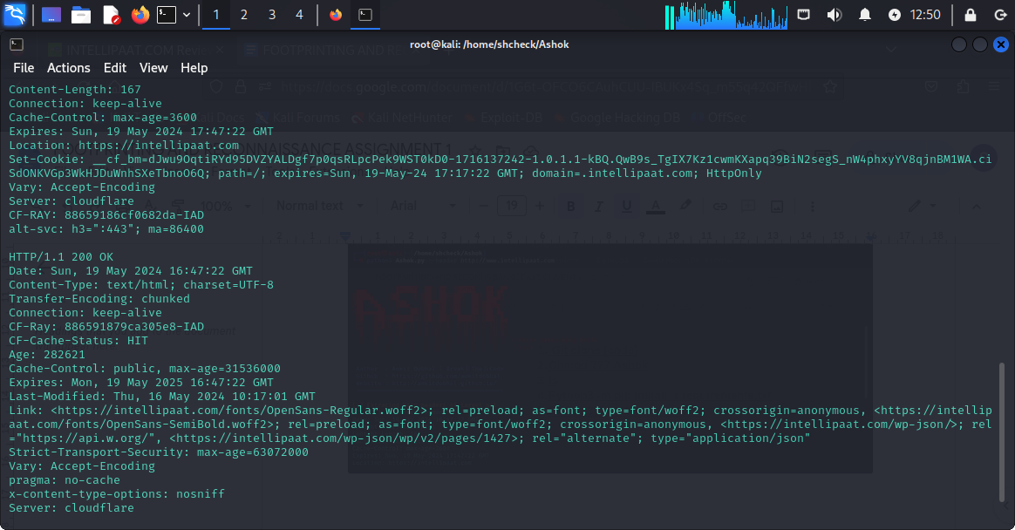

**Detailed analysis of https header analysis of** [**www.intellipaat.com**](http://www.intellipaat.com)

**Command:**

**Python3 Ashok.py - - subdomain intellipaat.com**

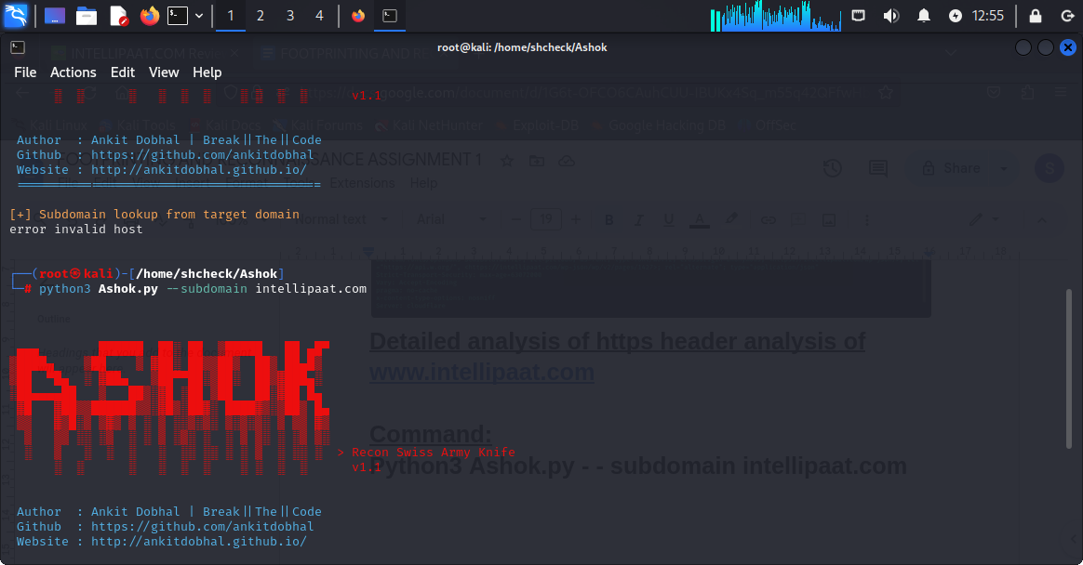

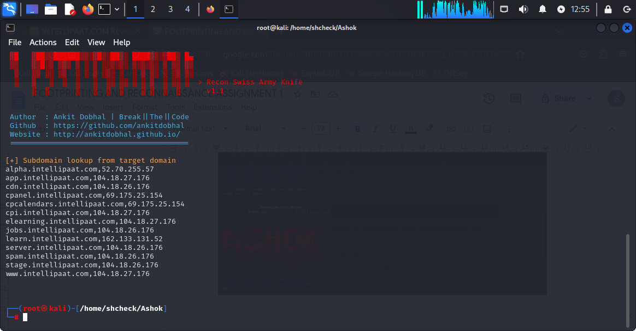

**Results subdomains of intellipaat.com**

1. **alpha.intellipaat.com[52.70.255.57]**
2. **app.intellipaat.com[104.18.27.176]**
3. **cdn.intellipaat.com[104.18.26.176]**
4. **cpanel.intellipaat.com[69.175.25.154]**
5. **elearning.intellipaat.com[104.18.27.176]**

**Observation: the result is as same as using**

**theHarvester -d intellipaat.com -l 200 -b hackertarget…….both of them gives us the same and equal number of subdomains of intellipaat.com.**

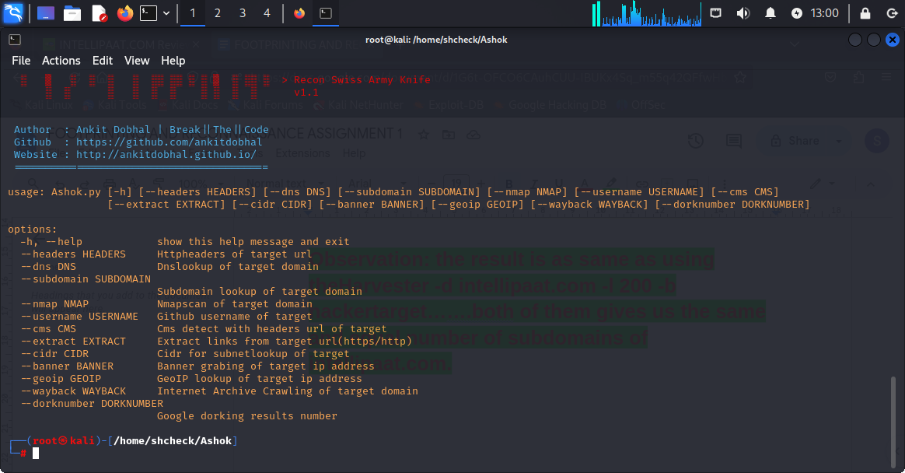

**These are the application of Ashok.py**

**DOMAIN INFO OF INTELLIPAAT.COM**

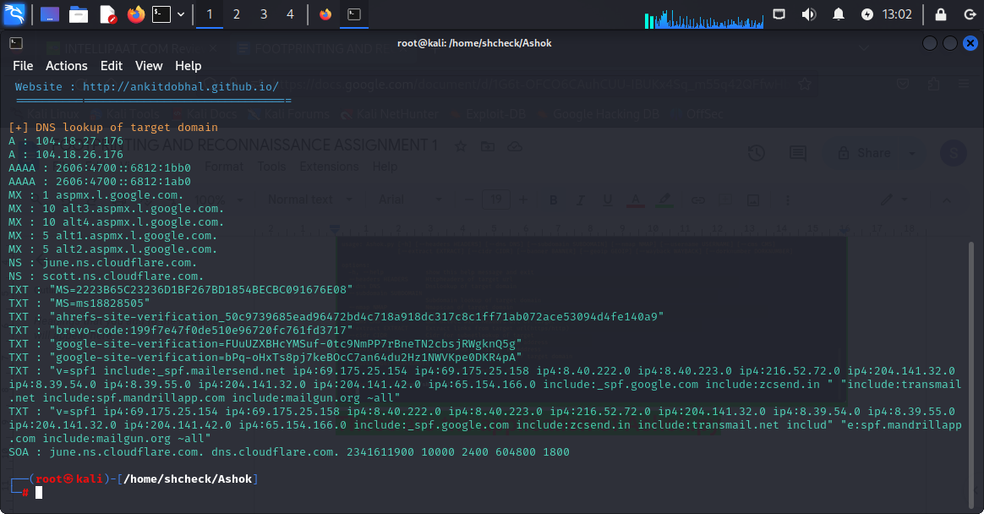

**SUBDOMAIN INFO OF INTELLIPAAT.COM**

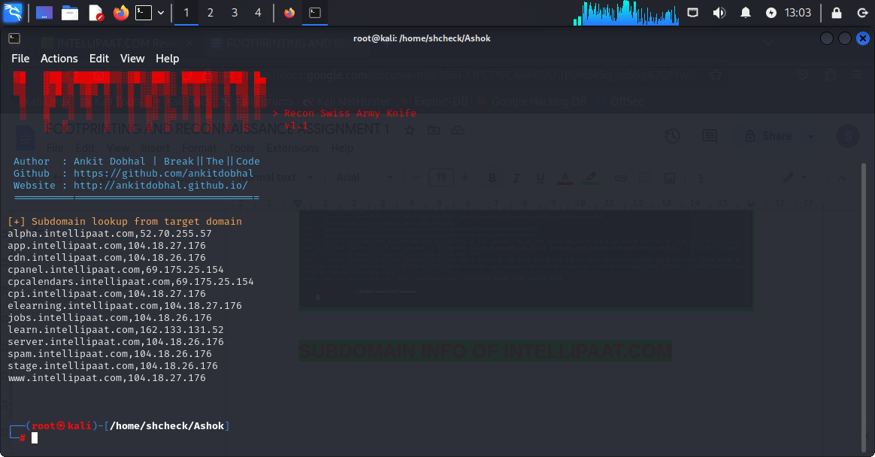

**Subdomain info of intellipaat.com**

**APPLICATION OF OSINT TOOLS FOR FOOTPRINTING AND RECONNAISSANCE:**

**WEBSITE USED: GITHUB**

**1.photon.py**

**Command:**

**Python3 photon.py - - url** [**https://www.intellipaat.com**](https://www.intellipaat.com)

**Step1:**

**Go to github and copy the code** [**https://github.com/s0md3v/Photon.git**](https://github.com/s0md3v/Photon.git)

**Step2:**

**Go to kali linux and type git clone** [**https://github.com/s0md3v/Photon.git**](https://github.com/s0md3v/Photon.git)

**Step3:**

**Chmod 777 photon**

**Step4:**

**Cd photon**

**Step 5:**

**Ls and find the file requirements.txt and type the command python3 -m pip install -r requirements.txt**

**Step6:**

**Python3 photon.py - - url** [**https://www.intellipaat.com**](https://www.intellipaat.com)

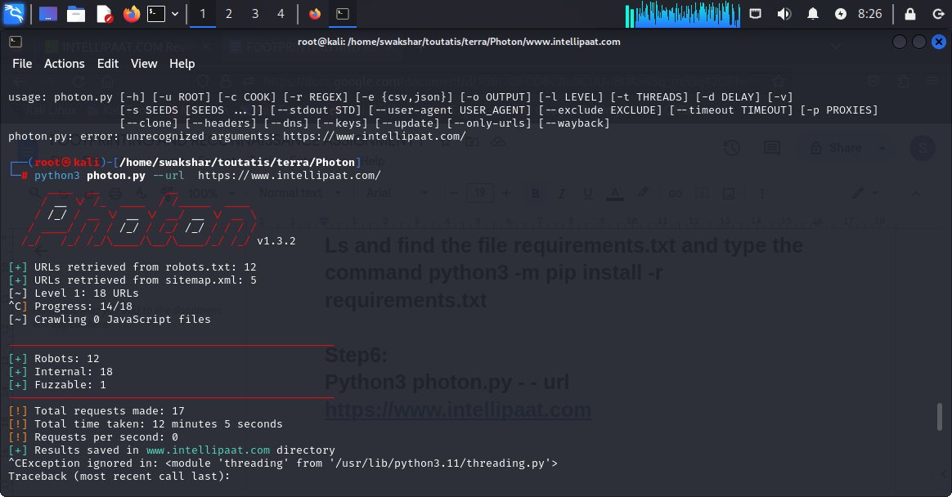

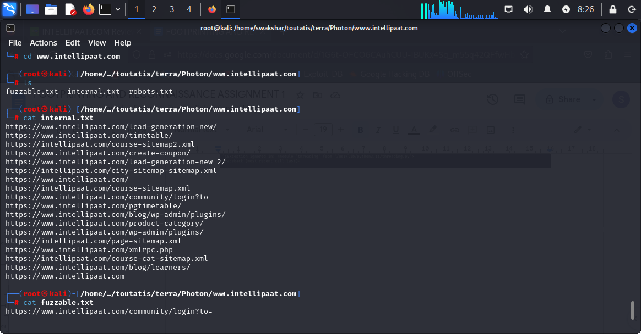

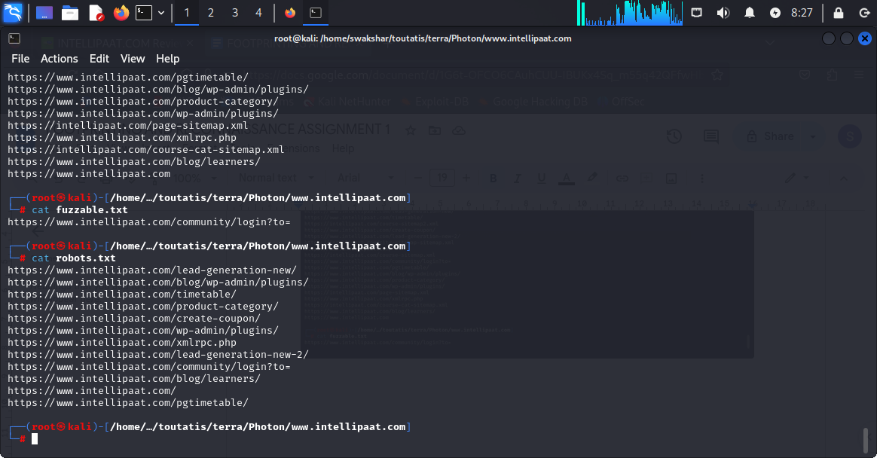

**AUTOMATICALLY IT CREATES A FOLDER NAMED** [**www.intellipaat.com**](http://www.intellipaat.com) **and after entering the folder we found three text files named**

**Internal.txt , robots.txt and fuzzable.txt**

**After typing the command cat [file name] we gather all the information about possible urls of intellipaat website.**

**2. PhoneInfoga**

**By using this tool we can derive the information about the contact numbers shown in intellipaat website**

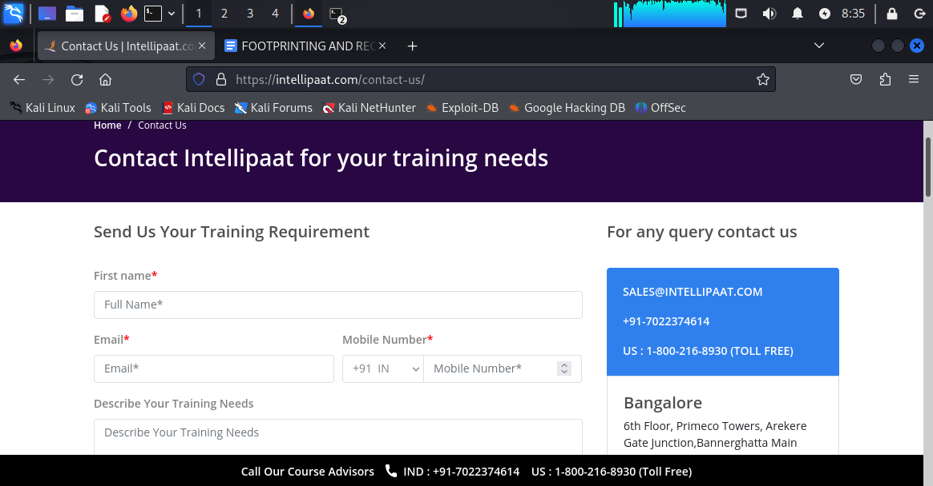

**Target :**

**1. +917022374614**

**2. +18002168930**

**Command: python3 phoneinfoga.py -n [number with country code]**

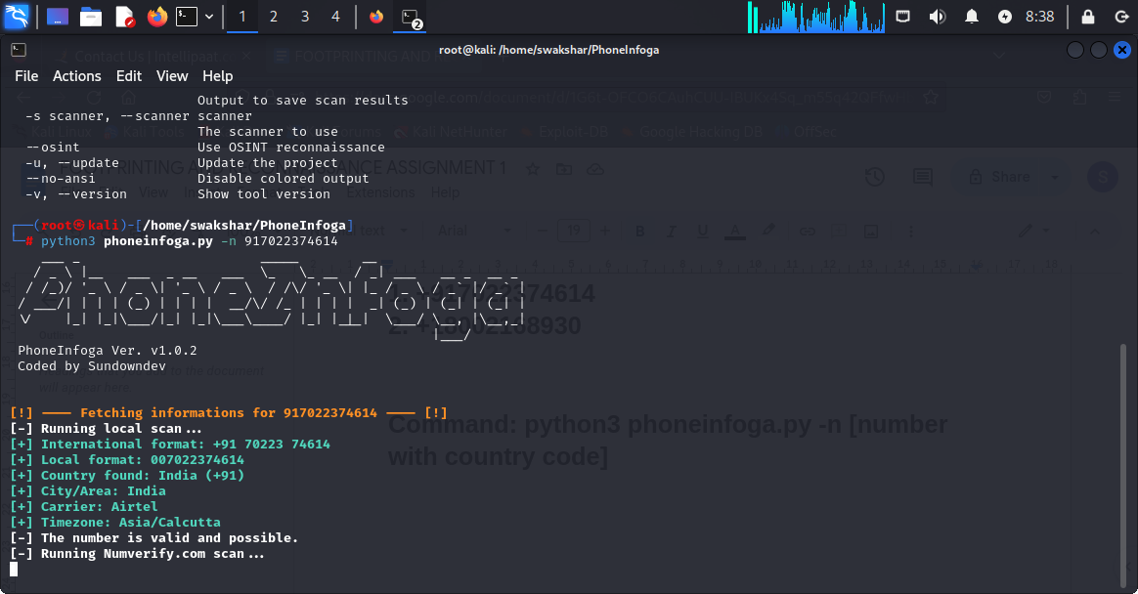

**As we can see that we can see some specific details about the number including “country code”, “time zone” and “name of the carrier(airtel)”.**

**EMAIL ADDRESS RESEARCH AND VERIFICATION:**

1. **There is a website called “haveibeenpawned” which is very popular about finding out any possible data breaches about your email information and any other relevant details.**

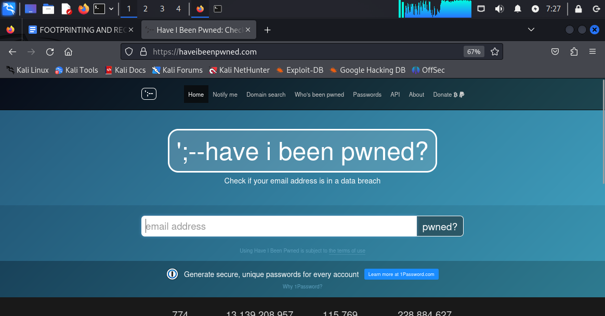

**THIS IS THE HOMEPAGE\DASHBOARD OF THE WEBSITE**

**We need to put our email address to verify any possible data breaches.**

1. [**chatterjeeswakshar436@gmail.com**](mailto:chatterjeeswakshar436@gmail.com)
2. [**mdimran007@gmail.com**](mailto:mdimran007@gmail.com)
3. [**support@intellipaat.com**](mailto:support@intellipaat.com)

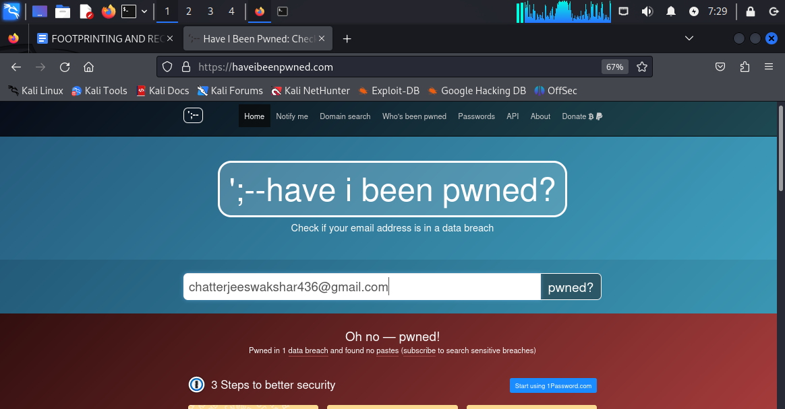

**Have put my email address and get the response that “ pwned in 1 data breach”**

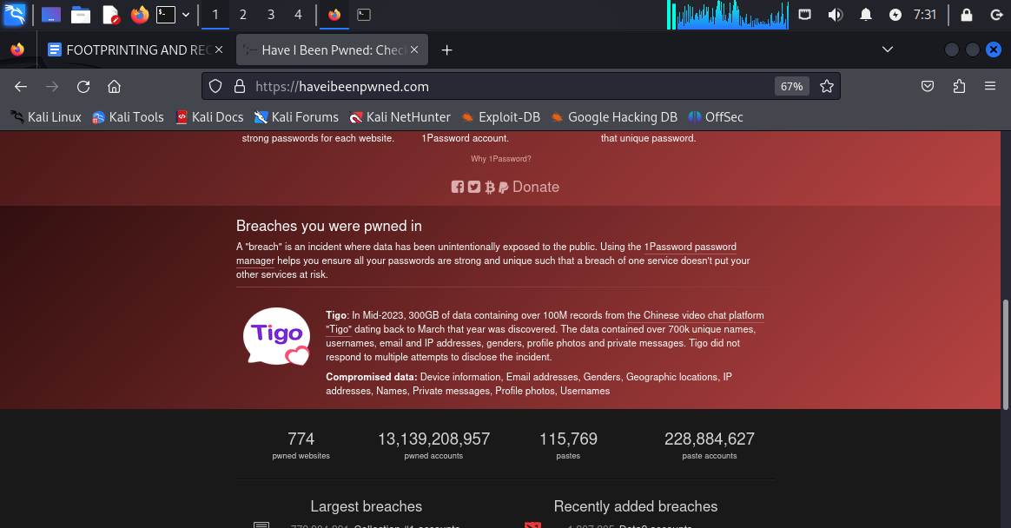

**Here we find that there is an application named “Tigo” which is a video chat application this specific email was breached**

**About company information:**

1. **Mid 2023 300gb of data containing about 100M records were breached on march 2023.**

1. **Data contained 700k unique names, usernames, email and IP addresses, genders, profile photos and private messages. Tigo did not respond to multiple attempts to disclose the incident.”**
2. **Compromised data: Device information, Email addresses, Genders, Geographic locations, IP addresses, Names, Private messages, Profile photos, Usernames**

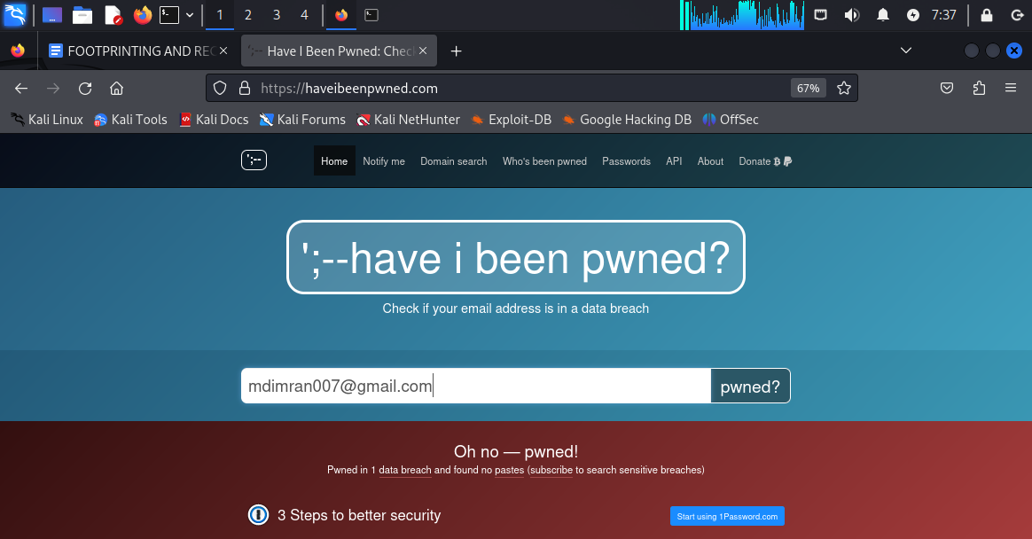

**NOW TRY THE EMAIL “mdimran007@gmailcom”**

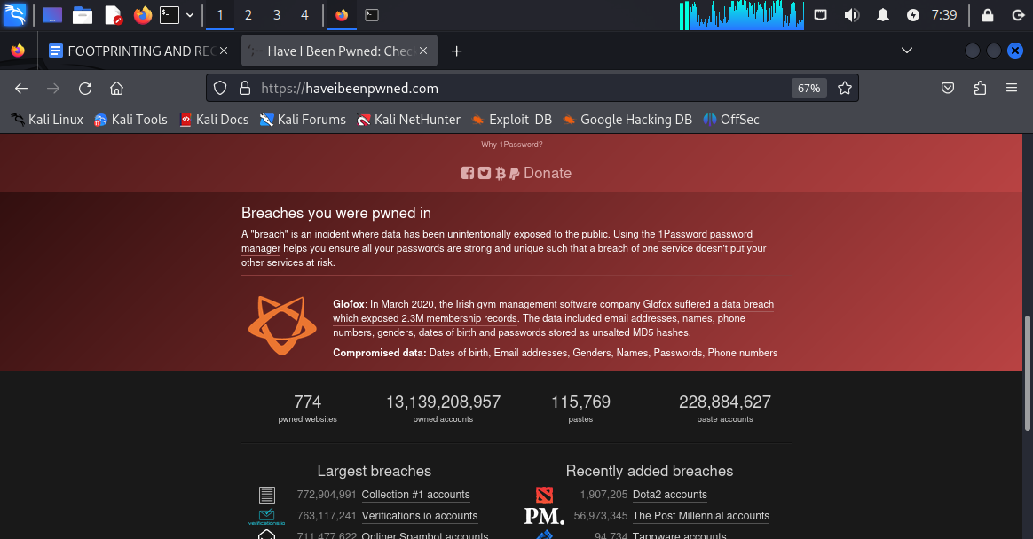

**Information:**



**Glofox: In March 2020, the Irish gym management software company** [**Glofox suffered a data breach which exposed 2.3M membership records**](https://www.irishtimes.com/business/technology/irish-start-up-glofox-investigates-possible-data-breach-1.4414837)**. The data included email addresses, names, phone numbers, genders, dates of birth and passwords stored as unsalted MD5 hashes.**

**Compromised data: Dates of birth, Email addresses, Genders, Names, Passwords, Phone numbers**

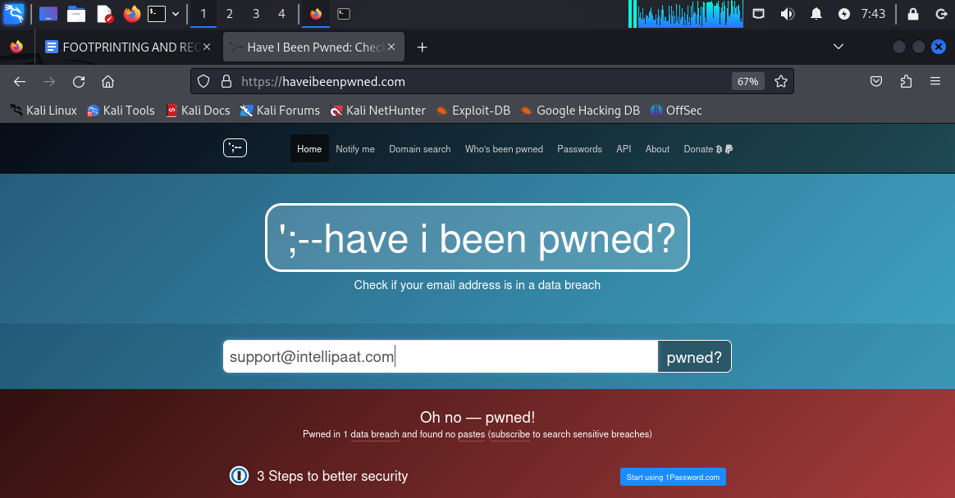

**Now try “**[**support@intellipaat.com**](mailto:support@intellipaat.com)**” and we have found 1 data breach incident.**

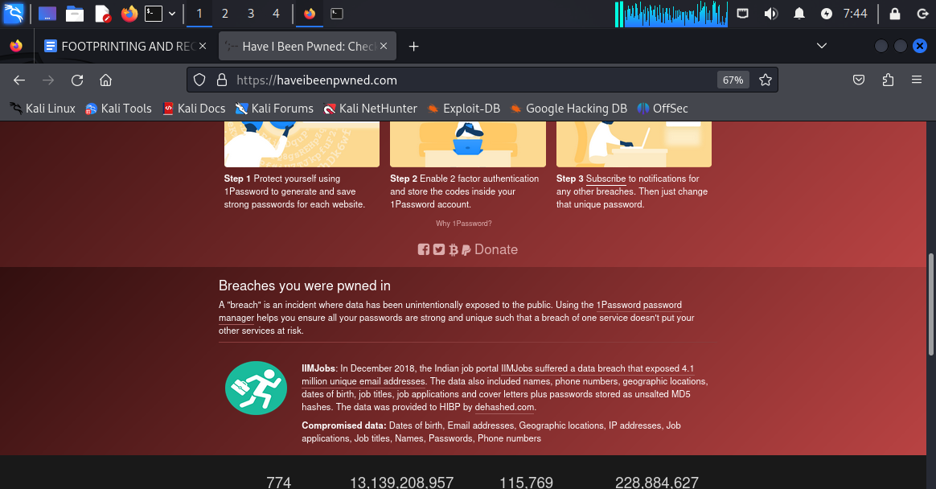

**Information: IIMJobs: In December 2018, the Indian job portal** [**IIMJobs suffered a data breach that exposed 4.1 million unique email addresses**](https://www.hackread.com/indian-job-portal-iimjobs-hacked-database-leaked/)**. The data also included names, phone numbers, geographic locations, dates of birth, job titles, job applications and cover letters plus passwords stored as unsalted MD5 hashes. The data was provided to HIBP by** [**dehashed.com**](https://dehashed.com/)**.**

**Compromised data: Dates of birth, Email addresses, Geographic locations, IP addresses, Job applications, Job titles, Names, Passwords, Phone numbers**

**EMAIL HEADER ANALYSIS:**

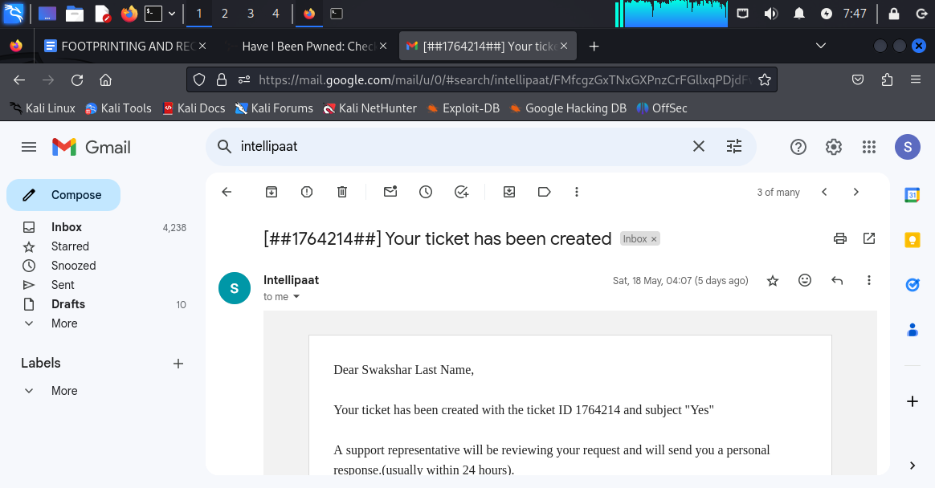

**We have opened an email received from “**[**support@intellipaat.com**](mailto:support@intellipaat.com)**”**

**Then click on the three “vertical dots” on the right hand sight >> click on show original from the drop down**

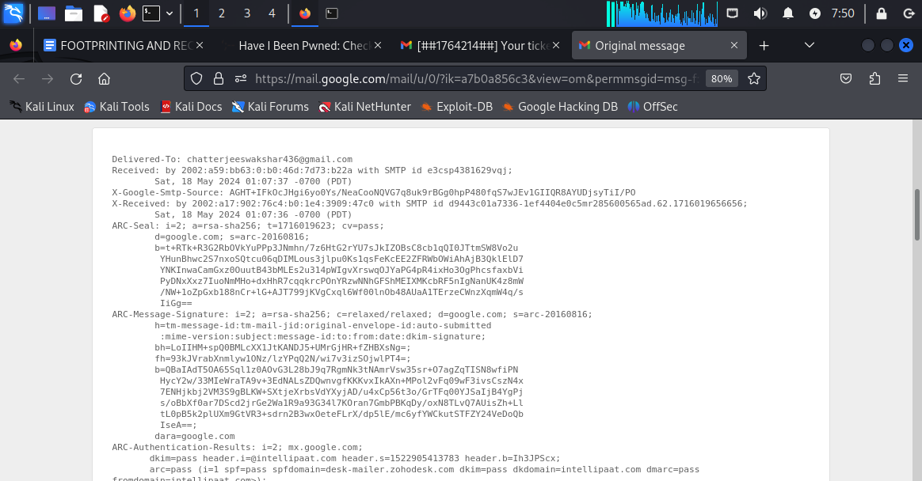

**Then we will find the original version of the email as per header/body/footer**

**We need to type ctrl+F AND type in “received: from”**

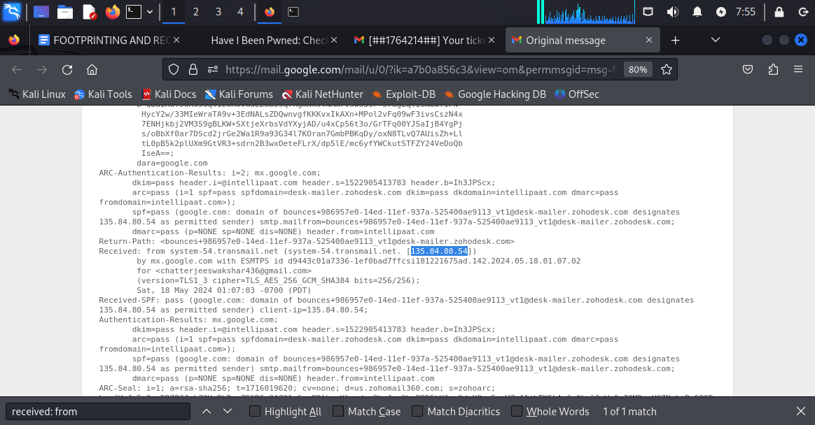

**We find the ip address “135.84.80.54”**

**Also we copy the header part as well which is from the 1st line till the body//content part.**

**Now go to MxToolbox**

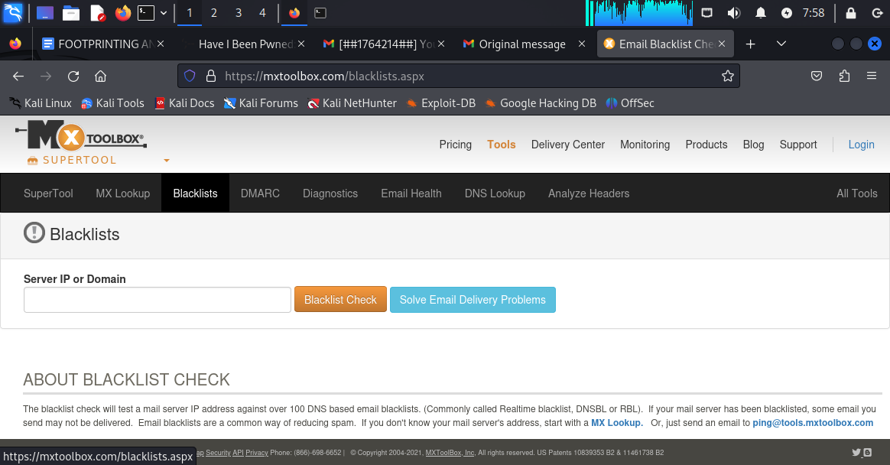

**Go to “Blacklists” SECTION and put the ip address in the box below which is “135.84.80.54”**

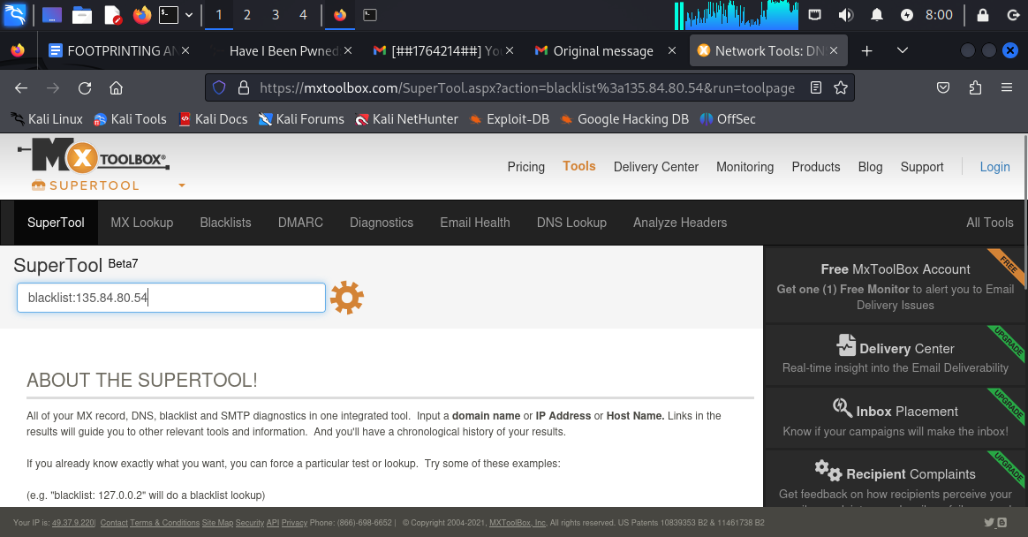

**Searching for blacklisting………3…2…1..**

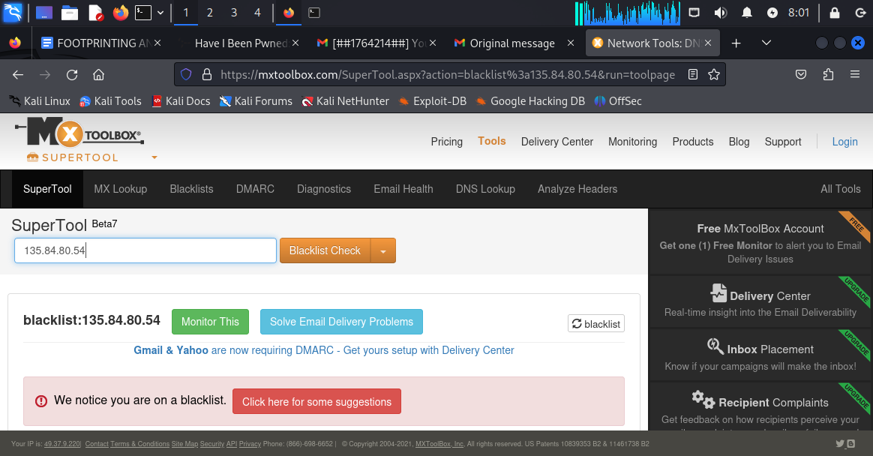

**It shows the ip address from which the email was received is on “BLACKLIST”.**

**Now we go to “analyse headers” and paste down the entire header of the email received from “**[**support@intellipaat.com**](mailto:support@intellipaat.com)**”**

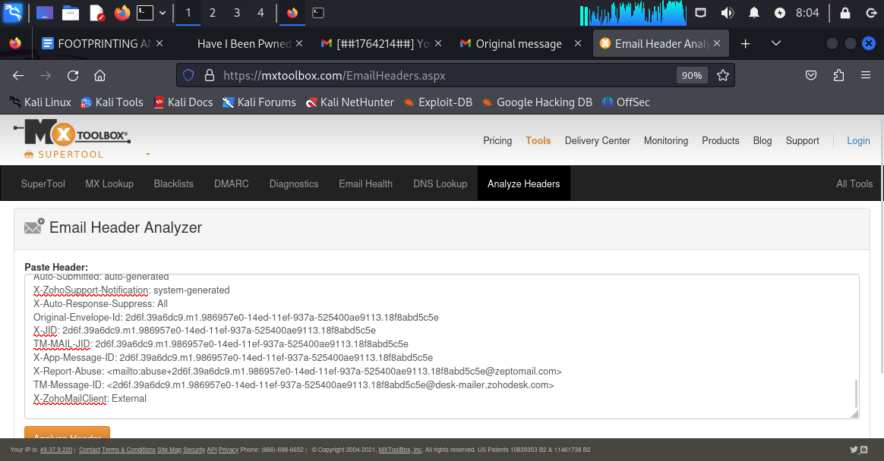

**Now we have pasted the “header” of the email in the analyse header section.**

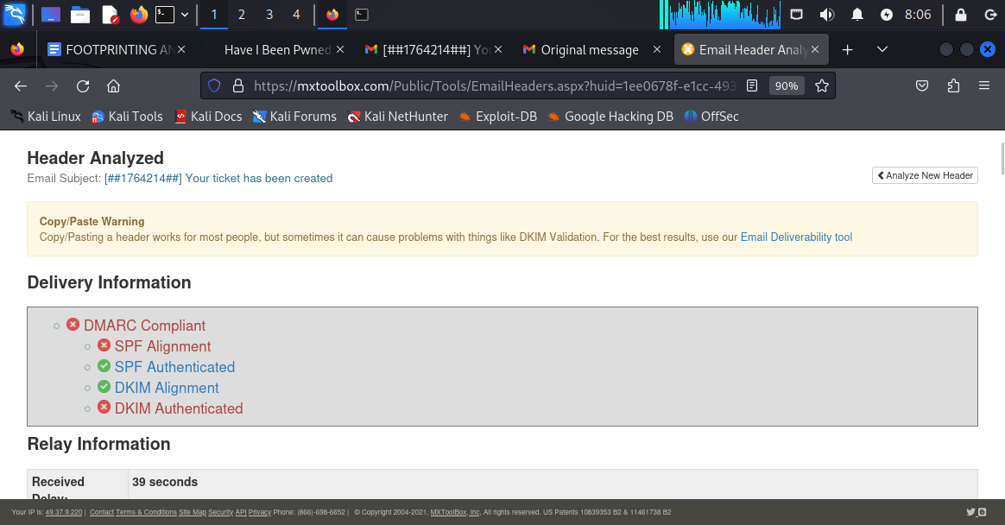

**Header analysis of emails received from “**[**support@intellipaat.com**](mailto:support@intellipaat.com)**”**

**SPF: SENDER POLICY FRAMEWORK**

**DKIM: DOMAINKEYS IDENTIFIED MAIL**

**THREE EMAIL SECURITY STANDARDS:**

1. **SPF**
2. **DKIM**
3. **DMARC ( DOMAIN BASED MESSAGE AUTHENTICATION , RECOVERY AND CONFORMANCE)**

**SPF info:**

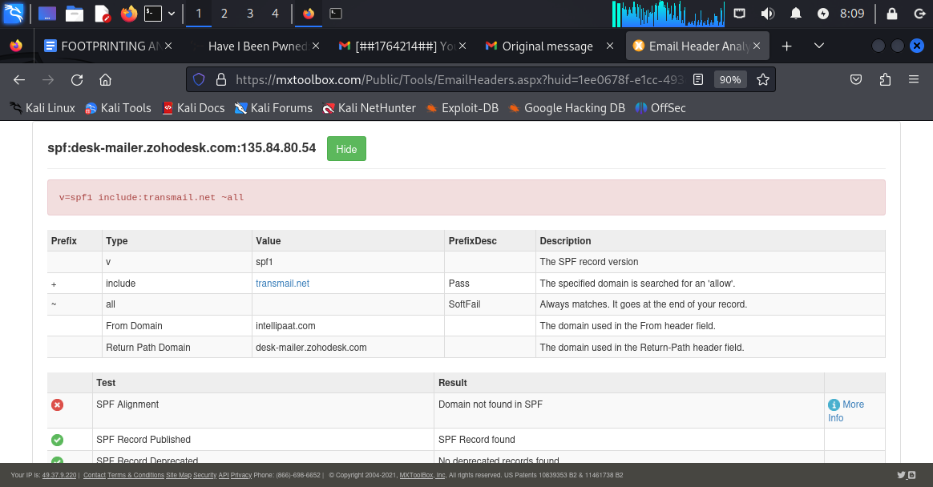

**DKIM Info:**

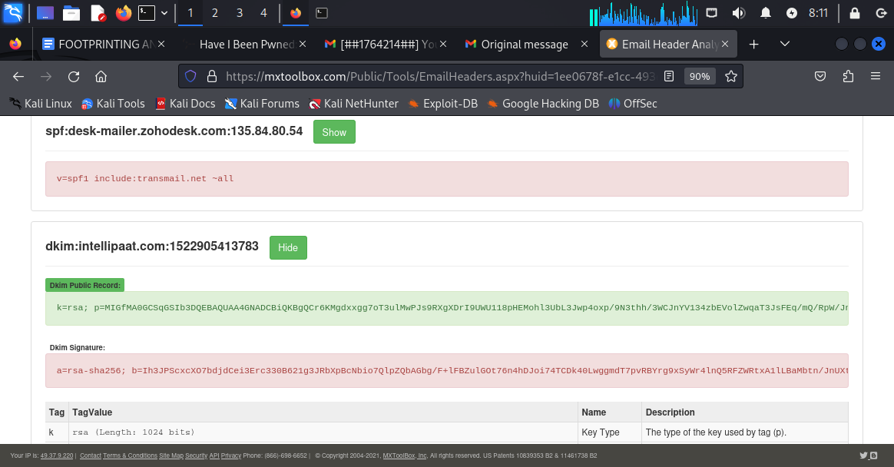

**DMARC Info:**

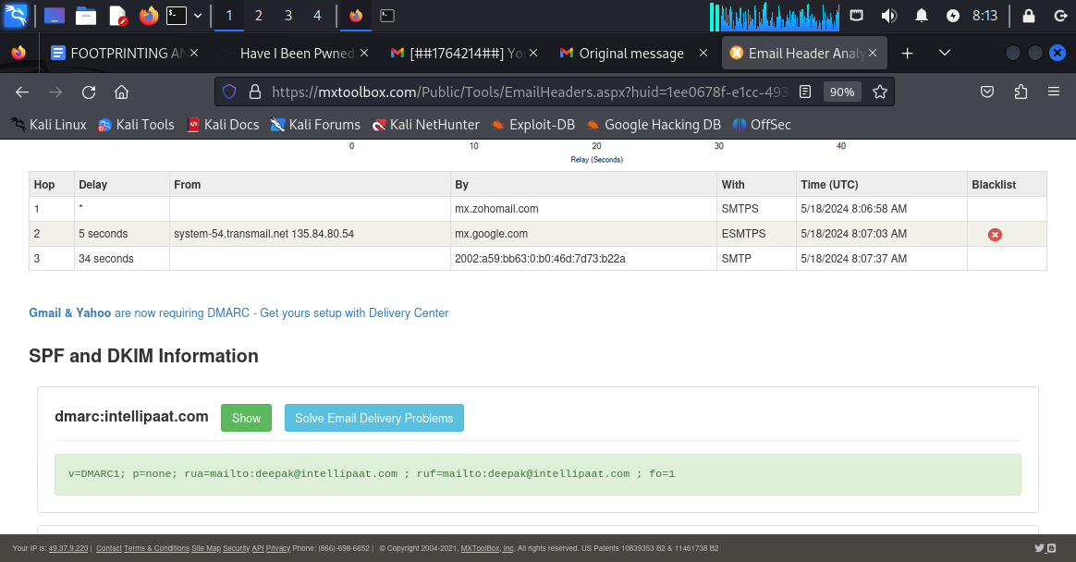

**Using THE OSINT named “metagoofil” to find out a certain numbers of pdf files from** [**www.intellipaat.com**](http://www.intellipaat.com) **.**

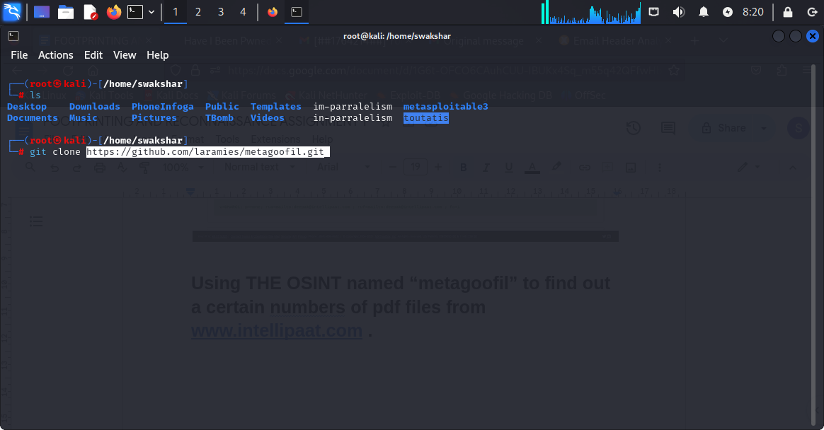

**Then type ls and cd metagoofil**

**Then python3 -m pip install -r requirements.txt**

**Them python3 metagoofil.py -d intellipaat.com -l 50 -t pdf -n 20**

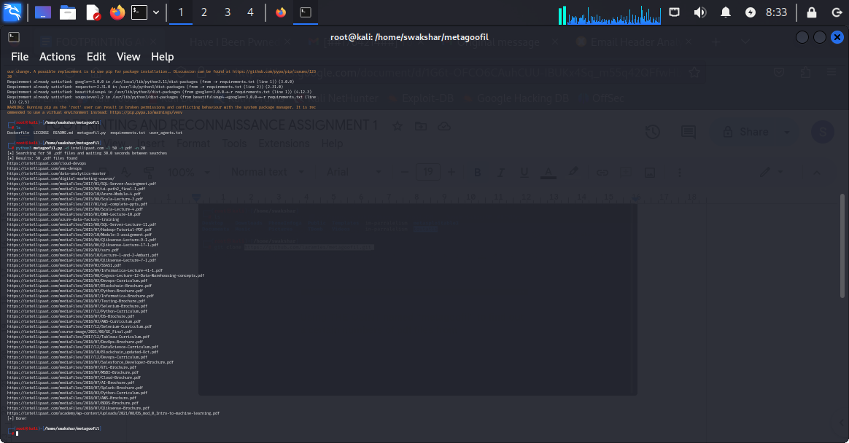

**These are the list of top 50 pdf links and if we just copy them and paste them in browser we will get to see the pdf file directly without downloading them.**

**4.finding username by using SHERLOCK**

**Step1: git clone [code]**

**Step2: ls>chmod 777 sherlock>cd sherlock**

**Step3: python3 -m pip install requirements.txt**

**Step4: python3 sherlock.py intellipaat**

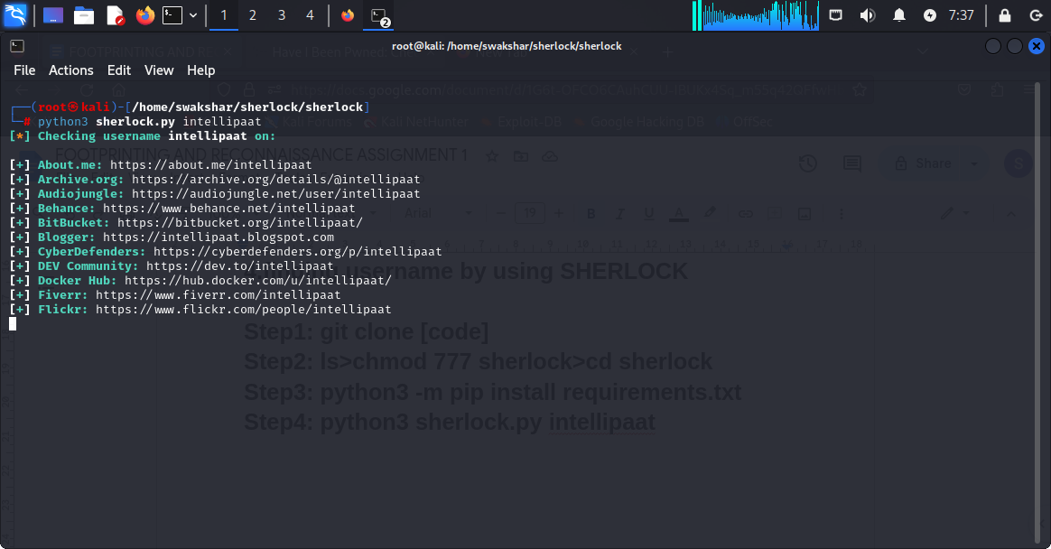

**These are the list of usernames**

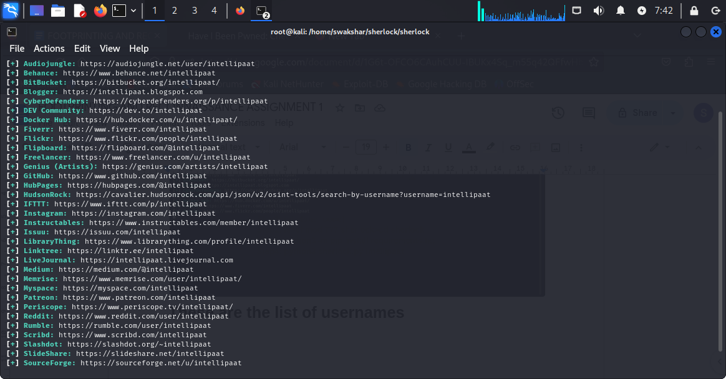

**These are the usernames and social media accounts of intellipaat .**

**USING centralops.net TO GET DOMAIN \\SUBDOMAIN\\REGISTRAR\\IP INFORMATION ABOUT INTELLIPAAT**

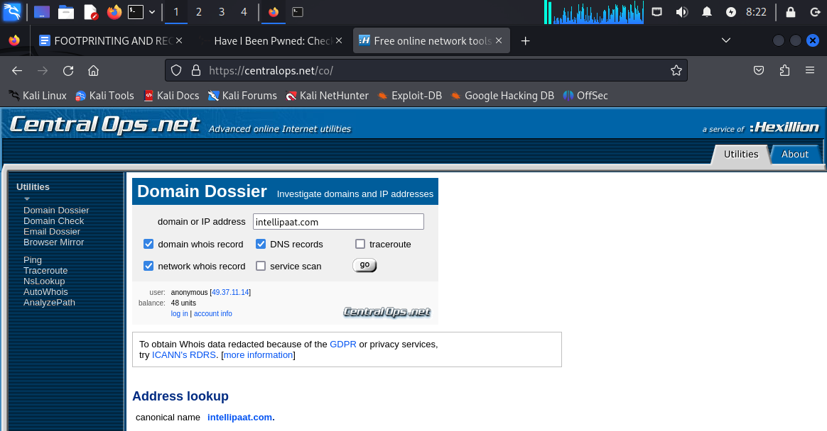

**Homepage of centralops.net and searching for intellipaat.com**

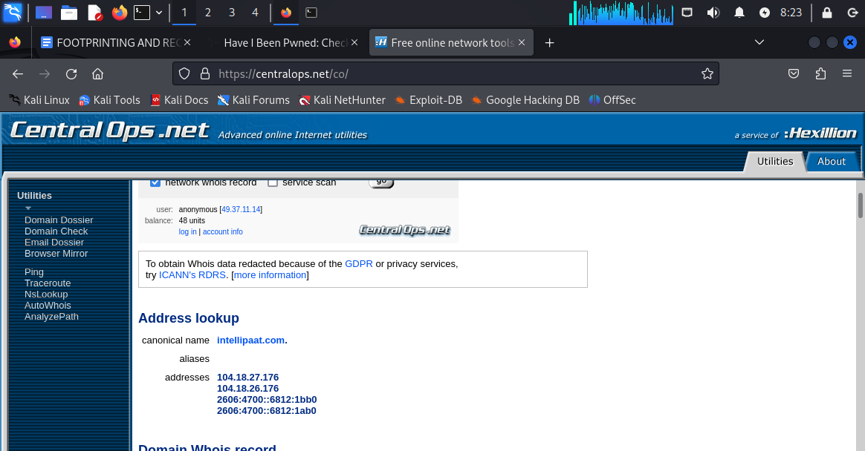

**IP address records (both ipv4 and ipv6) for intellipaat.com domain**

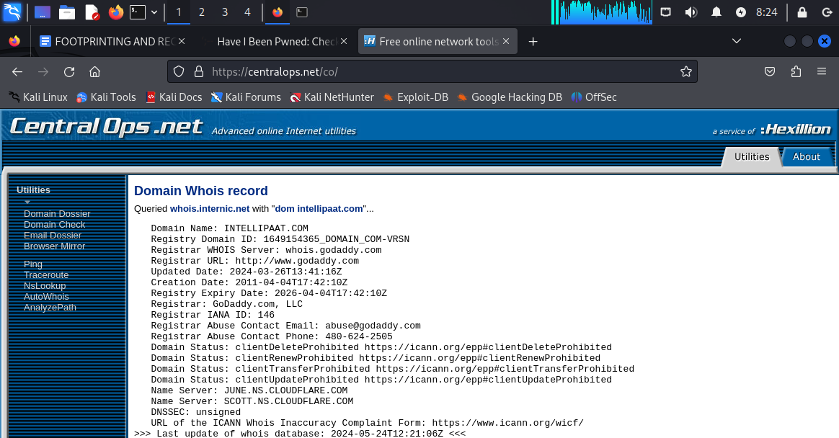

**Domain whois record**

**Domain name: INTELLIPAAT.COM**

**Registrar name:GODADDY.COM**

**Registrar url:**[**http://www.godaddy.com/**](http://www.godaddy.com/)

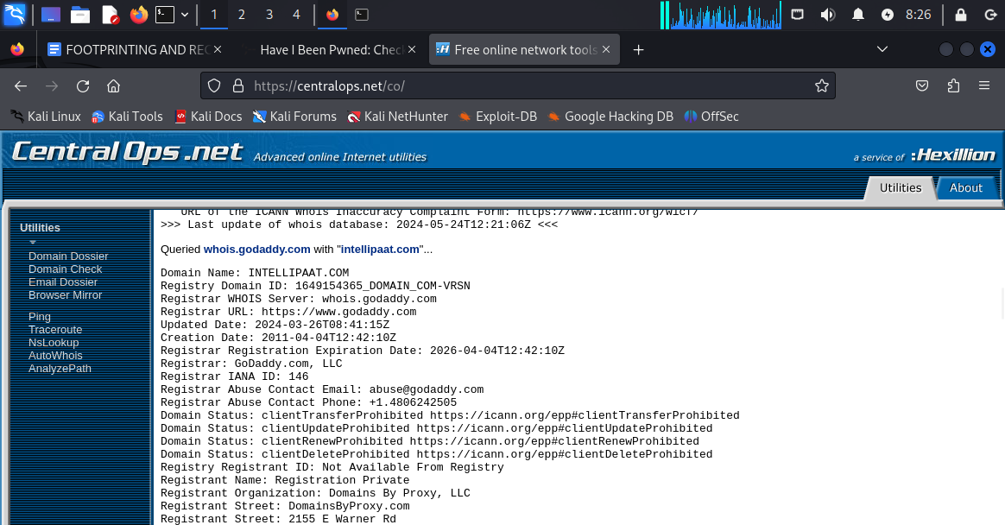

**Whois godaddy.com information**

**Registrant street address: 2155 east warner road,tempe,arizona ,85254,usa**

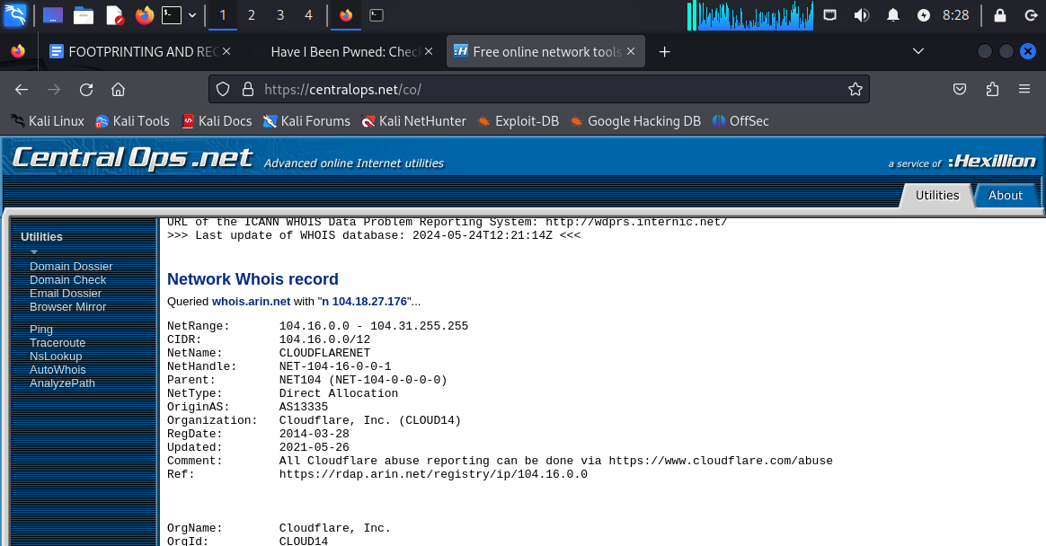

**Network whois record**

**Net range : 104.16.0.0 - 104.31.255.255**

**CIDR:104.16.0.0/12**

**Netblock owner:cloudflarenet**

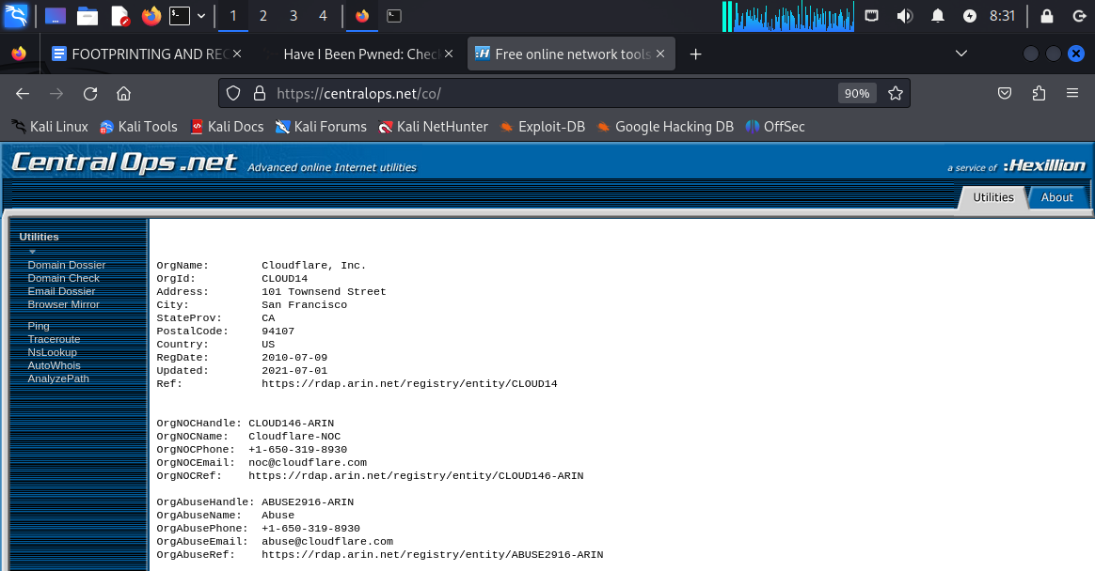

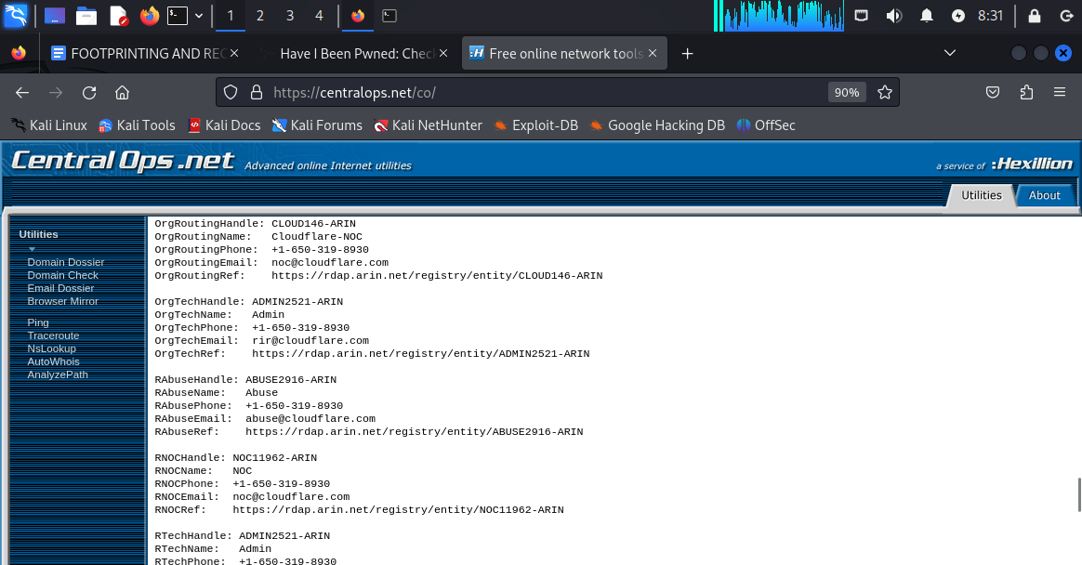

**Information and whois record of cloudflare, llc**

**Using shodan.io to fetch information about intellipaat.com**

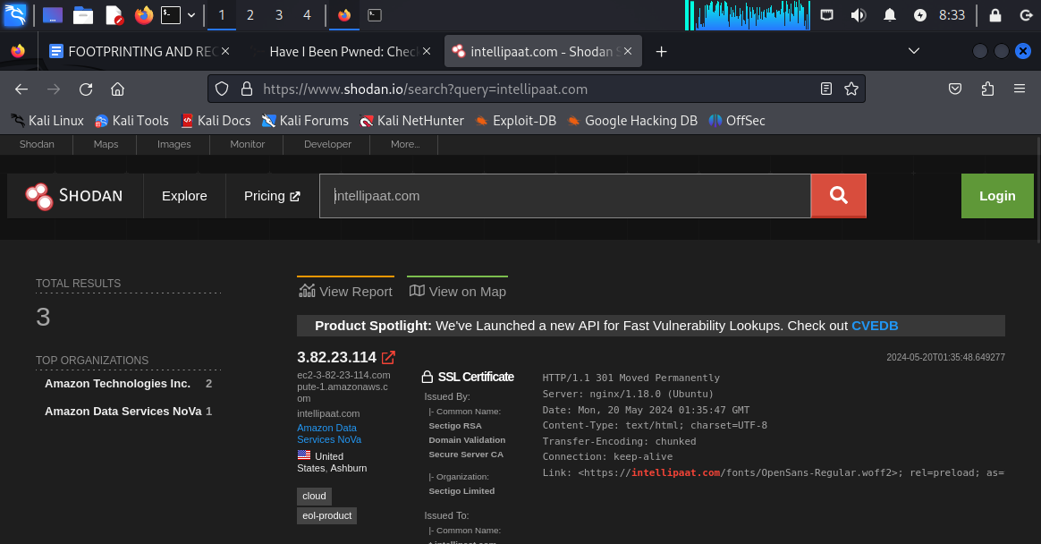

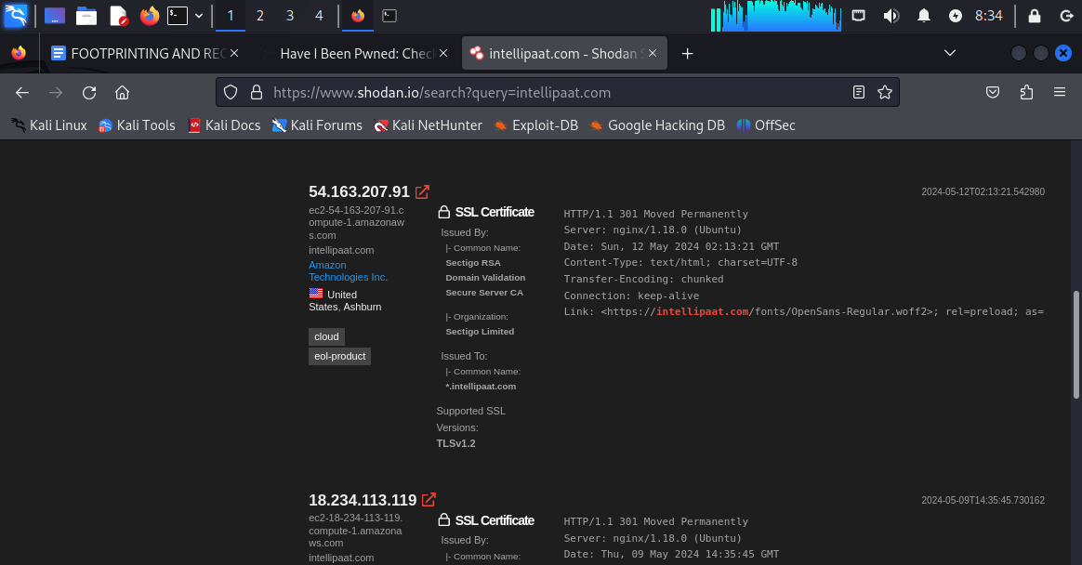

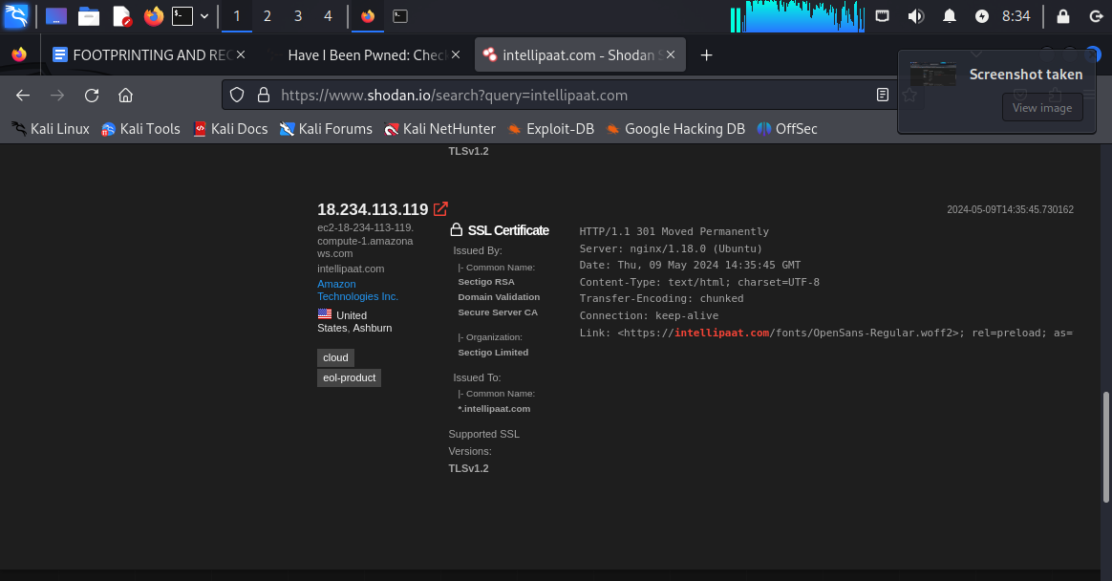

**All the information about intellipaat.com along with SSL(secure socket layer)certificate information.**

**USING WHOIS.DOMAINTOOLS.COM TO FIND OUT DOMAIN INFORMATION ABOUT INTELLIPAAT.COM**

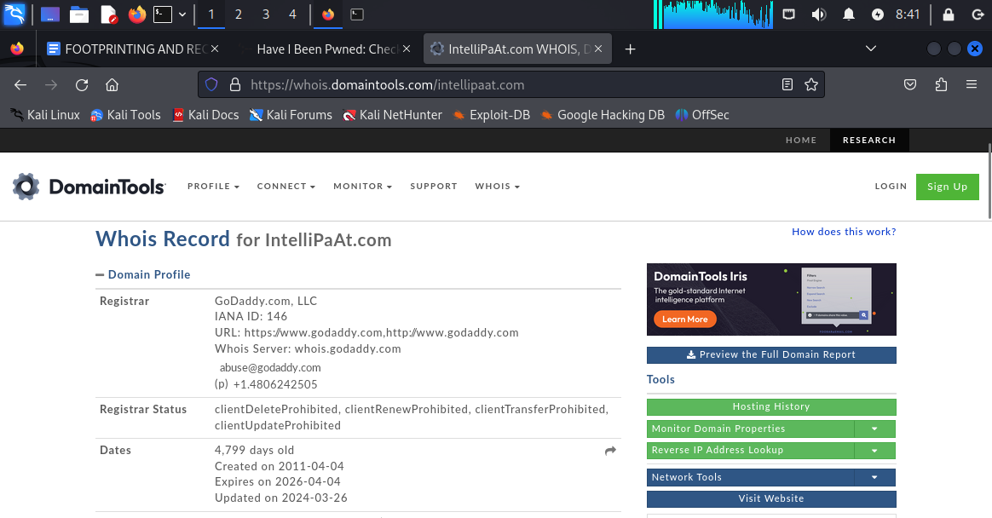

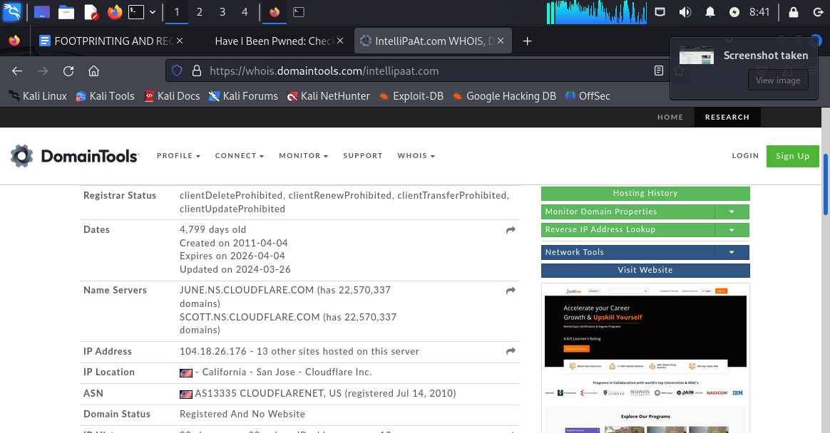

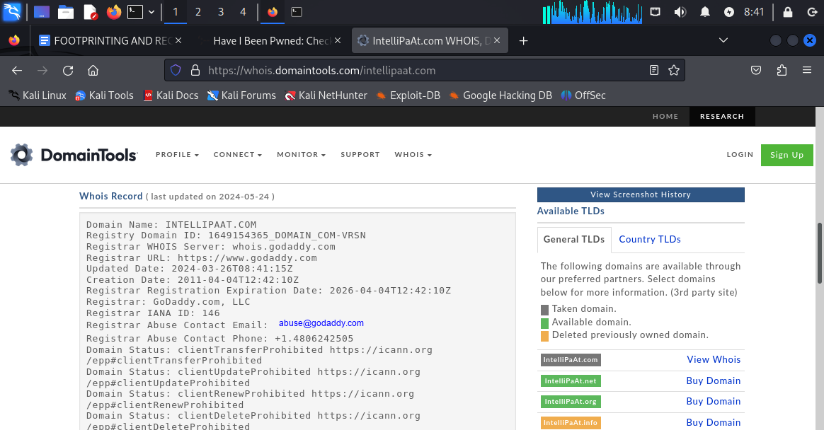

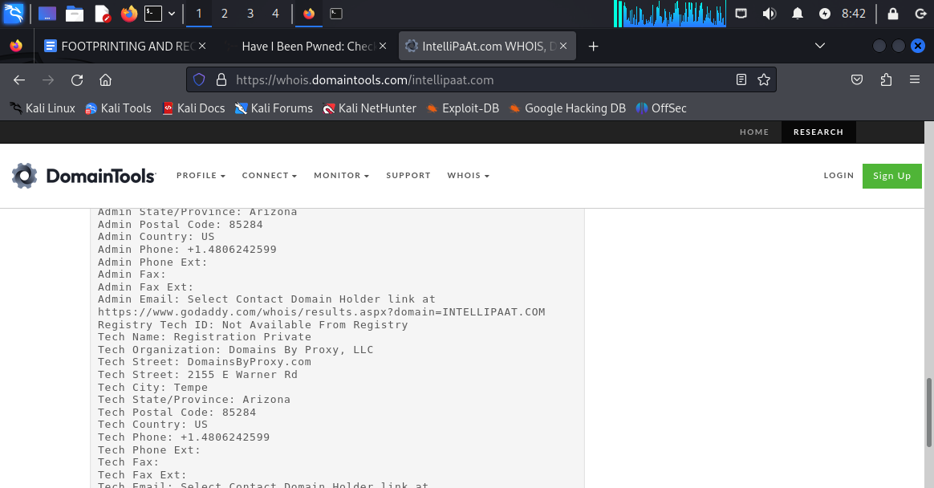

**RESULT ALMOST SIMILAR TO centralops.net**

**Domain information gathering of intellipaat.com**

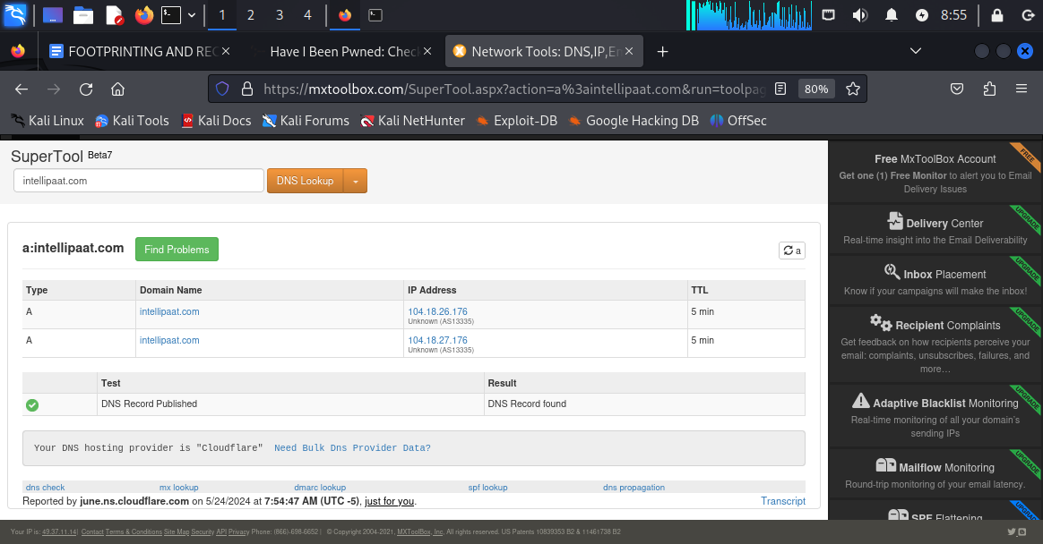

**Using mxtoolbox to gather dns information.**

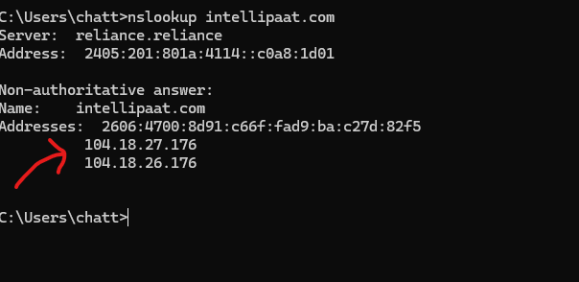

**Windows terminal nslookup command to find out domain information about intellipaat.com**

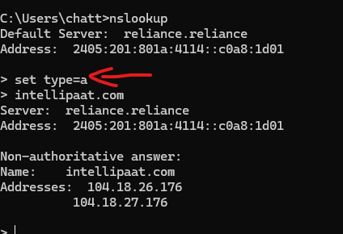

**BY USING set type=a command**

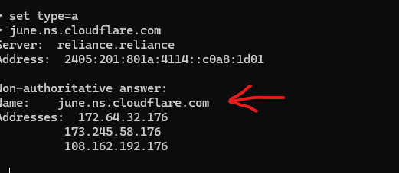

**Domain information for june.ns.cloudeflare.com which has come from the network whois information of intellipaat.com**

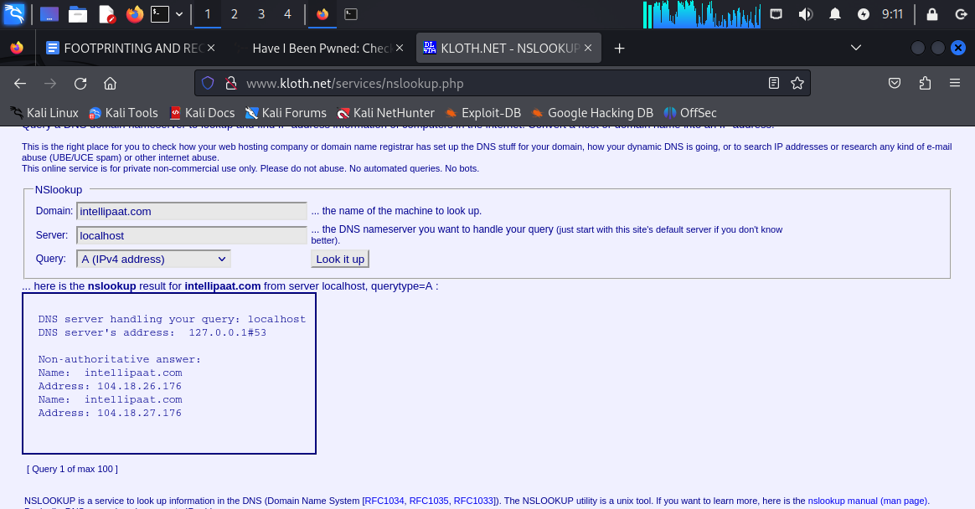

**Domain information from kloth.net website**

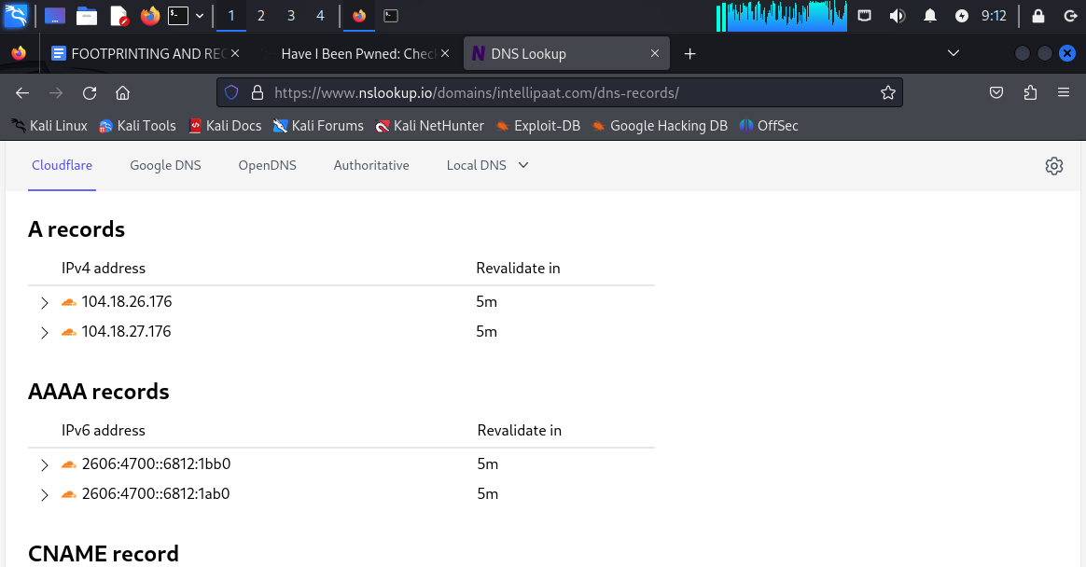

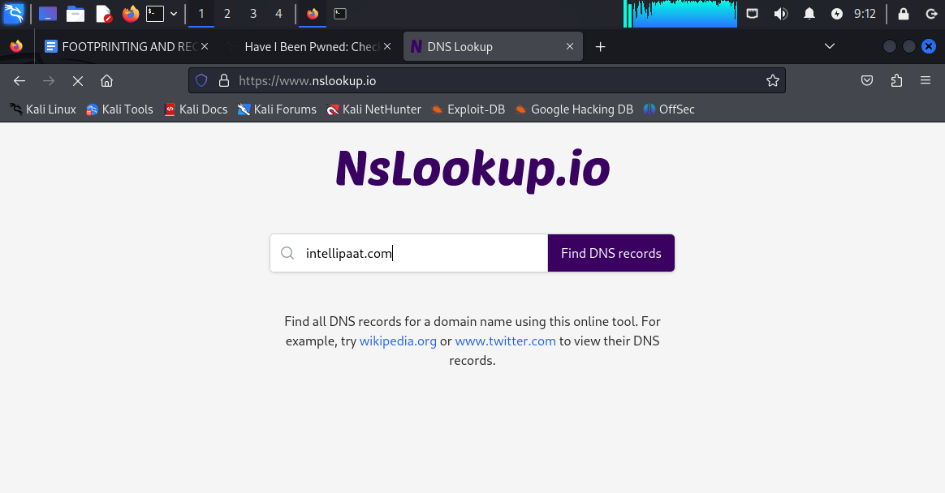

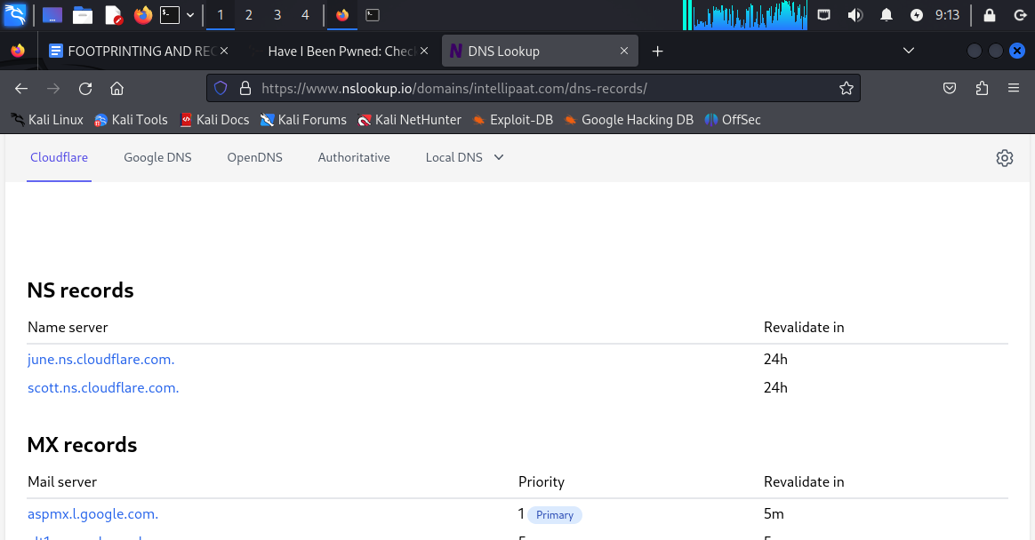

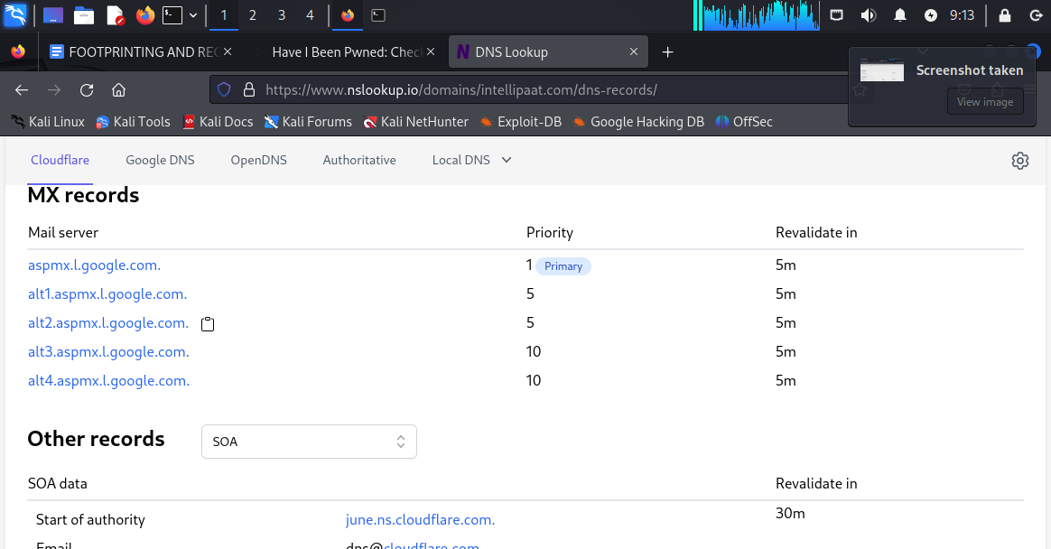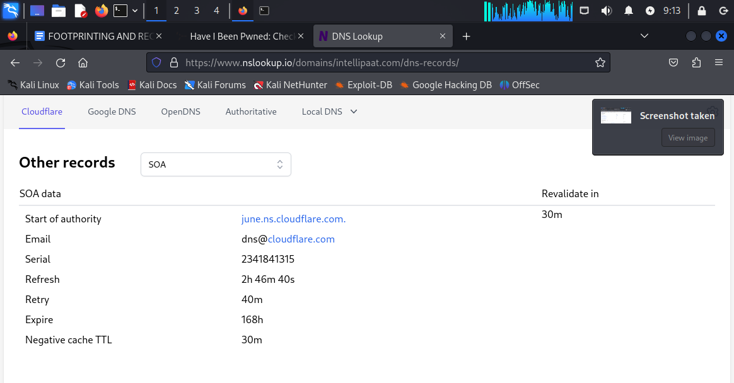

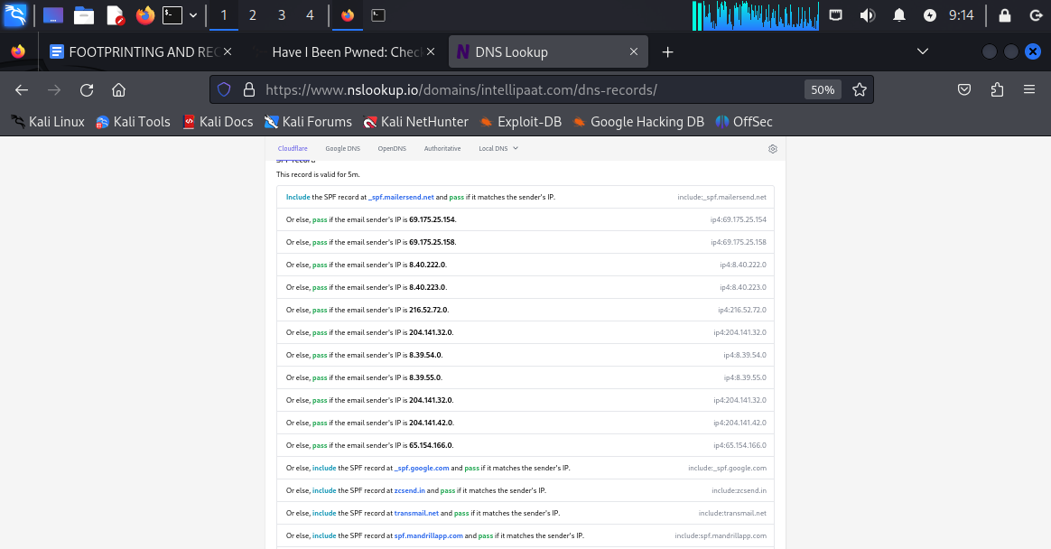

**ALL THE INFORMATION ARE MORE DETAILED IN nslookup website compared to kloth.net website**

**The information is about AA ,AAAA ip records, dns records, network whois info, spf records(sender policy framework and it mentions the specific email ips address which are verified and not blacklisted)**

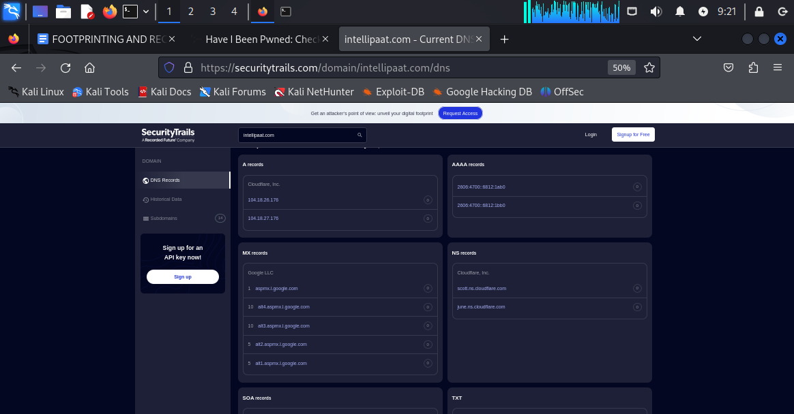

**Information gathered from securitytrails.com**

**USING THE COMMAND dig IN ORDER TO GET DOMAIN INFORMATION:**

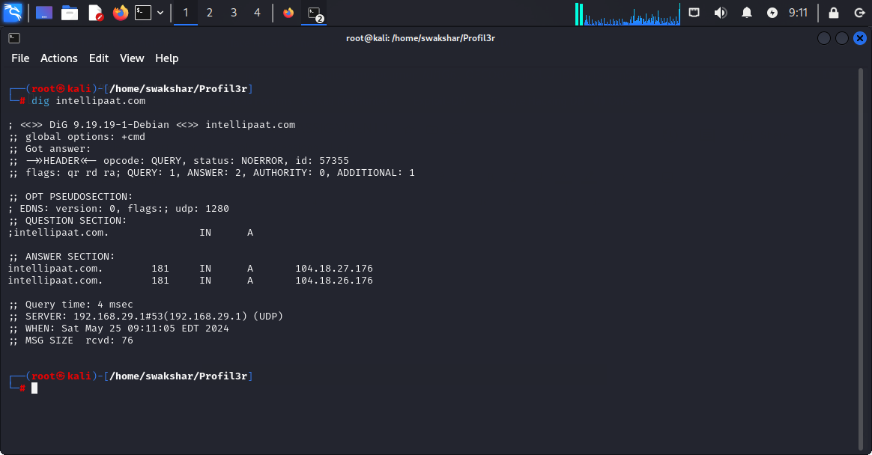

**WE GET THE IPV4 address of the specific domain intellipaat.com**

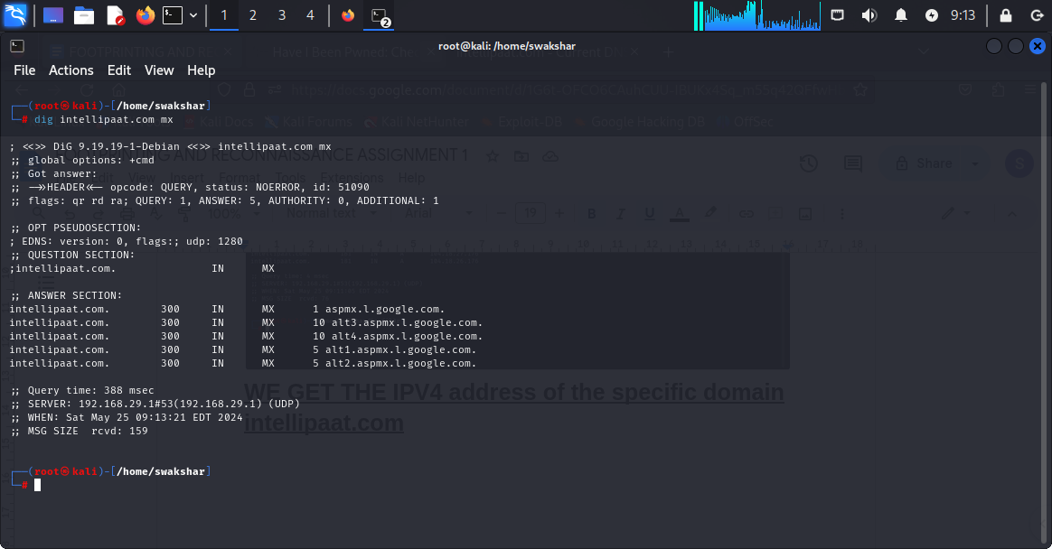

**Command : dig intellipaat.com mx**

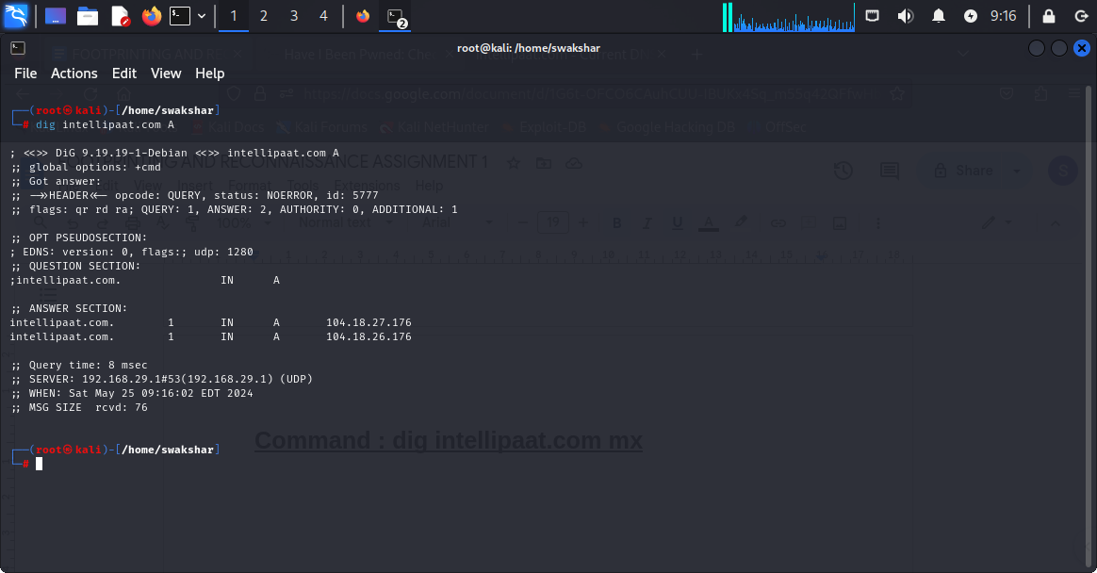

**COMMAND: dig intellipaat.com A**

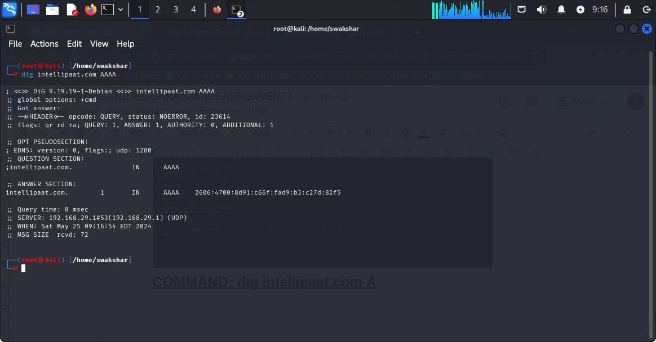

**COMMAND: dig intellipaat.com AAAA**

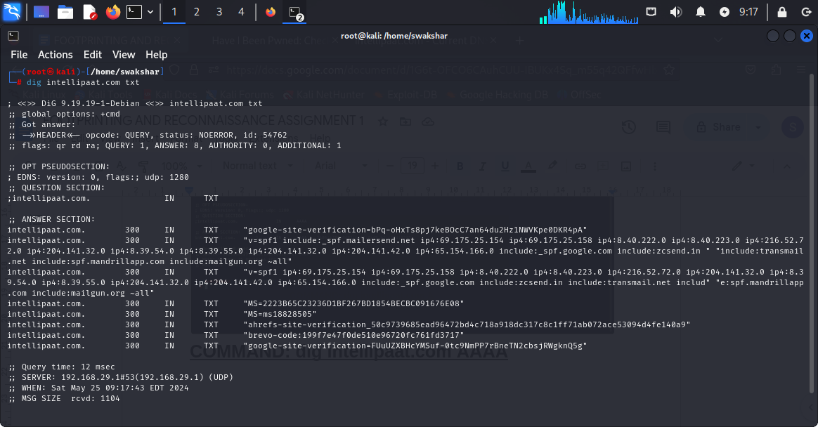

**Command: dig intellipaat.com txt to find TXT records.**

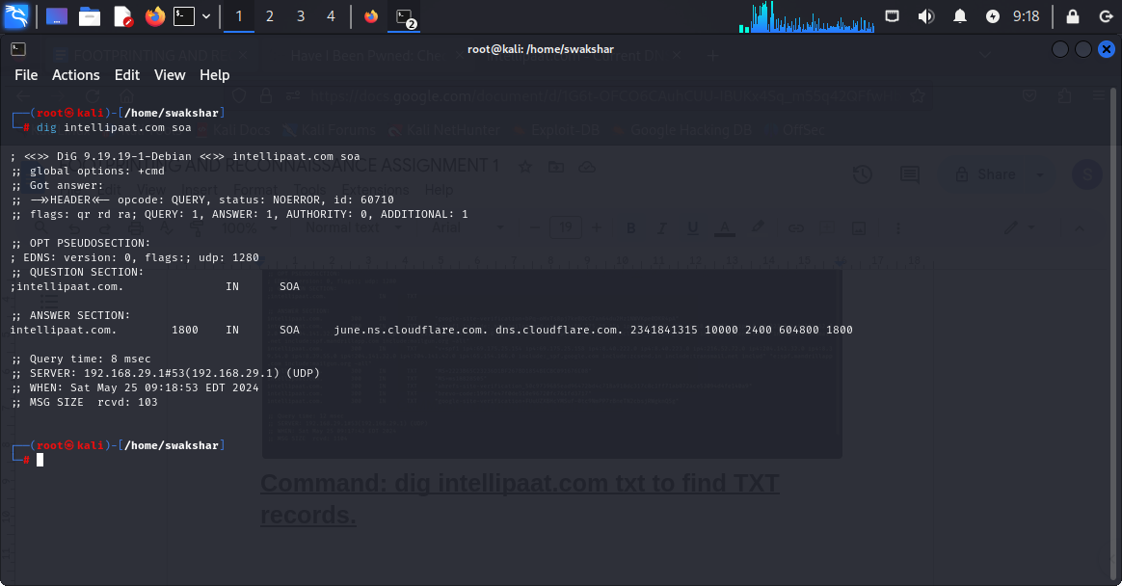

**Command: dig intellipaat.com soa which is state of authority.**

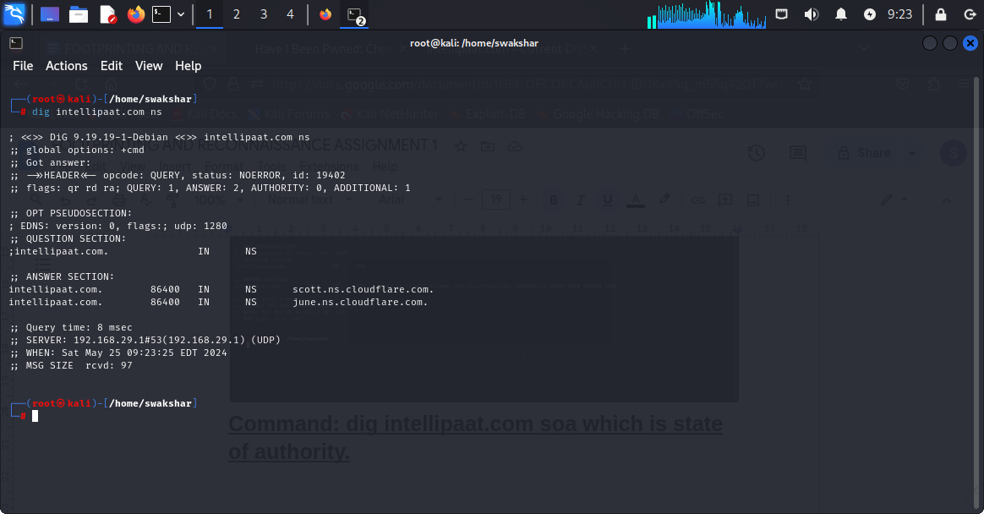

**Command: dig intellipaat.com ns**

**\*\*\*\*\*\*\*\*\*\*\*\*\*\*\*\*\*\*\*\*\*\*\*\*end of assignment\*\*\*\*\*\*\*\*\*\*\*\*\*\*\*\*\*\*\*\*\*\*\*\*\*\*\*\*\*\*\*\*\***